**ESSENCE**

**Mechanical Team Report**

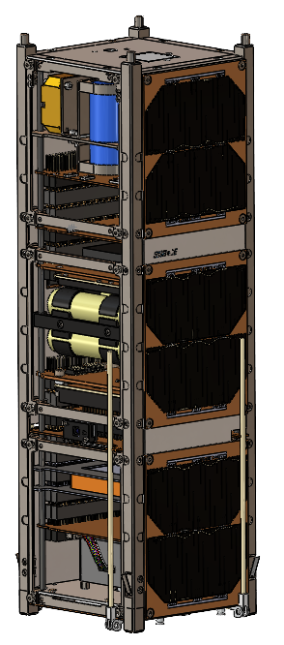

**Mechanical Team**

**Aug. 01 2021**

**ABSTRACT**

CubeSats or microsatellites are an ever-increasing field of study and research in universities around the globe due to their ever-growing usefulness in space science and technology within the modern era. The report below describes the educational learning behind the process of how a Cubesat is designed and the function and usage of individual Cubesat components. The report also touches on the testing a final manufactured form of a Cubesat has to go through to become ready for usage in the space environment. Expanding on this Cubesat University space projects like the one presented in this report almost always rely on a thorough manufacturing and integration plan to ensure completion and project success. As stated above, both the Cubesat manufacturing and integration procedures and the thermal and vibration analysis work described in this report are for the ESSENCE Cubesat program, which is run by a variety of Canadian Post-secondary schools across Ontario.

**TABLE OF CONTENTS**

**1.0 INTRODUCTION**1

1.1 ESSENCE CUBESAT PROGRAM SUMMARY 1

1.1.1 PURPOSE AND SCOPE OF REPORT 1

1.2 MISSION OBJECTIVES AND INTEGRATION TIMELINE 1

1.2.1 OBJECTIVES OF THE MISSION 1

1.2.2 CUBESAT INTEGRATION OVERVIEW 1

1.3 CUBESAT STRUCTURE AND DESIGN 2

1.3.1 DESIGN OBJECTIVES 2

1.3.1.1 PRIMARY OBJECTIVES 2

1.3.2.2 SECONDARY OBJECTIVES 2

1.3.2 CUBESAT STRUCTURE SPECIFICATIONS 2

1.3.3 DESIGN SPECIFICATIONS AND CONSTRAINTS 3

1.4 MATERIALS AND RESEARCH AND MODELING 3

1.4.1 FUNDAMENTAL REACH AND MATERIALS 3

1.4.2 MATERIAL 3

**2.0 MANUFACTURING PLAN**4

2.1 MANUFACTURING 4

2.1.1 DRAWINGS 4

2.1.1.1 PART DRAWINGS 4

2.1.1.2 ASSEMBLY DRAWINGS 4

2.1.2 COMPONENTS AND THEIR FUNCTIONS 5

2.2.2.1 FIRST UNIT COMPONENTS 5

2.2.2.2 SECOND UNIT COMPONENTS 5

2.2.2.3 THIRD UNIT COMPONENTS 7

2.2 PROTOTYPING AND DESIGN 8

2.2.1 PROTOTYPING 8

2.2.2 INTEGRATION EXERCISES 8

2.2.3 FLAT-SAT PREPARATION 8

**3.0 STRUCTURAL COMPONENTS**9

3.1 EXTERIOR COMPONENTS AND HARDWARE 9

3.1.1 CHASSIS 9

3.1.2 EXTERIOR PLATES 9

3.1.3 HARDWARE 10

3.1.3.1 Screws 11

3.1.3.2 Nuts 11

3.1.3.3 Standoffs 11

**4.0 SUB-ASSEMBLY**12

4.1 INTRO INTO SUB ASSEMBLY 12

4.2 CAMERA MOUNTING ASSEMBLY 12

4.3 ATTITUDE AND CONTROL HOUSING UNIT 13

4.4 MAGNETORQUER 13

4.5 ADCS UNIT SUBSYSTEM 14

**5.0 MAIN ASSEMBLY**15

5.0 INTRO: MAIN-ASSEMBLY 15

5.1.1 FIRST UNIT PROCEDURE. 15

5.1.2 SECOND UNIT PROCEDURE 16

5.1.3 THIRD UNIT PROCEDURE 16

5.1.4 DEPLOYABLES AND MECHANISMS 17

5.1.4.1 BURN WIRE MECHANISM 17

5.1.4.2 PLUNGER AND RAIL SWITCHES AND RBF PIN 18

5.1.5 HARNESSES AND CONNECTORS 18

**6.0 THERMAL ANALYSIS**20

6.1 THERMAL THEORY 20

6.2  HEAT TRANSFER MODES 20

6.2.1 RADIATION 20

6.2.2 CONVECTION 21

6.2.3 CONDUCTION 21

6.3 ENVIRONMENT LOW EARTH ORBIT 22

6.3.1 SOLAR RADIATION 22

6.3.2 ALBEDO RADIATION 23

6.3.3 EARTH IR 23

6.4 PANDEMIC LIMITATIONS 24

**7.0 VIBRATION ANALYSIS**25

7.1 PURPOSE OF VIBRATION TESTING 25

7.2 ANALYSIS ASSUMPTIONS 25

**8.0 INFORMATIONAL METRICS**25

8.1 MASS BUDGET 25

8.2 VOLUME BUDGET 28

8.3 THERMAL ANALYSIS AND CUBESAT TEMPERATURE RANGES **Error! Bookmark not defined.**

**9.0 MECHANICAL GROUND SUPPORT EQUIPMENT** **Error! Bookmark not defined.**

9.1 STOWAGE CASE 31

9.2 PROGRAMING AND POWER HARNESS 32

9.3 TESTING RIG 32

**10.0 REFERENCES AND CONCLUSION**33

10.1 ACKNOWLEDGEMENTS 34

10.2 LIST OF FIGURES 34

10.2.1 Body Plates 34

10.2.2 Chassis 37

10.2.3 Components 38

10.2.4 Connectors 42

10.2.5 Custom PCBs 43

10.3 LIST OF TABLES 45

**REFERENCES**46

# 

# 1.0 INTRODUCTION

## 1.1 ESSENCE CUBESAT PROGRAM SUMMARY

### 1.1.1 PURPOSE AND SCOPE OF REPORT

The purpose and scope of this report is to describe in great detail the ESSENCE teams integration plan. The integration plan is intended to highlight and define the team's amalgamation strategies for every critical component of Cube-Sat's lower-level elements into constructing the final 3U satellite. The report's integration plan provides the reader insight into how this integration was done in 3 ways. Firstly the report goes into great detail on describing the coordinated integration effort in between several subteams to working toward the completion of the implementation strategy, secondly by conveying to the reader what needs to be done in each integration step, and finally identifying the required resources and when and where they were needed throughout the course of the project to act as a road map for future Cube-Sat teams.

## 1.2 MISSION OBJECTIVES AND INTEGRATION TIMELINE

### 1.2.1 OBJECTIVES OF THE MISSION

The Essence team’s primary mission is to help train competent personnel in multiple subsystems to demonstrate the capability to work efficiently as a team to build the essential skills that could be required in industry. The project will demonstrate attitude control as it monitors the thawing of permafrost in the northern part of Canada, along with the ice in the arctic regions that are in the visible spectrum. Essence will also investigate space weather as it will measure energetic solar protons, and monitor forest coverage. This will demonstrate ESA standard space-ground communications using the cube satellite platform to give us a better understanding of the changes in topography.

### 1.2.2 CUBESAT INTEGRATION OVERVIEW

Within the scope of the manufacture, integration, and testing of the ESSENCE project, to streamline the process, the team had chosen to follow the route of other Cubesat design teams in setting out necessary guidelines to accomplish the assembling of the spacecraft.

Prepare Engineering Data:

* Completion of digital 3D modelling and obtaining specifications from suppliers
* Obtaining vital engineering data (i.e., thermal, C.O.M, altitude)

Assembly Manufacture Component:

* Manufacture planning
* procurement of materials and obtaining components from suppliers.
* Assembly and testing of individual components

Component Qualifying and Integration of Test Spacecraft:

* Quality assurance by way of Functional testing
* Environmental exposure testing
* Final Mechanical assembly of CubeSat

## 1.3 CUBESAT STRUCTURE AND DESIGN

### 1.3.1 DESIGN OBJECTIVES

The design must be capable of surviving extreme conditions such as temperature fluctuation, radiation, and pressure change. It must also withstand the vibrations of transport to the International space station to ensure all components are operational during the lifespan of the mission.

#### 1.3.1.1 PRIMARY OBJECTIVES

* + Provide a design solution that meets all the required constraints.
* Provide a design solution that meets all the required constraints.
* Ensure the design will work for all other teams involved in the Essence mission.
* Provide a thorough thermal analysis with results that prove the cube satellite can withstand its environment.
* Provide a solution for any problems that may occur during these processes.

#### 1.3.2.2 SECONDARY OBJECTIVES

* Perform thermal analysis in the specific orbit at its Maximum and minimum altitude.
* Provide a vibration analysis on the cube satellite.
* Identify ground support equipment.
* Demonstrate the Deployment mechanisms.

### 1.3.2 CUBESAT STRUCTURE SPECIFICATIONS

The CubeSat structure is as follows a simplistic with guidelines that set baseline satellite measurements to be 10 cm × 10 cm × 10 cm and to weigh less than 1.4 kg. This configuration is commonly known as "one unit" or 1U. However, the essence program is constructing a 3U CubeSat structure with dimensions of 10 cm × 10 cm × 30 cm and a total final mass of roughly 2.85 kg. Within each of the units, there are specific instruments and devices of note. Each of these units' functions and how they were assembled and integrated to contribute to the overall design is laid out in the report below.

### 1.3.3 DESIGN SPECIFICATIONS AND CONSTRAINTS

While designing the cubesat and thermal subsystems, the mechanical team has encountered many design constraints. The biggest design constraint being the size of the cubesat. When the ESSENCE mission first began, we only planned on designing a 2U CubeSat. Due to the constraints in volume, we had to upsize to 3U. Another design constraint that we ran into was the center of mass. Nanoracks require the CubeSat center of mass to be within 2cm of its geometric center. This led to many changes in the design in order to meet these needs. The center of mass now stands well within this constraint at 1.12 cm from the geometric center. Nanoracks have a required maximum mass of 8.485 kg for 3U cubesats. Our design sits well within this constraint as well at a mass of 2.48 kg. The last major design constraint is the operational temperature of each of the components within the cubesat. These operational temperatures are shown on *Table 1* Appendix A, and based on our thermal analysis, the temperature of the cubesat will sit well within these ranges.

## 1.4 MATERIALS AND RESEARCH AND MODELING

### 1.4.1 FUNDAMENTAL REACH AND MATERIALS

During the course of the project, many materials will be required in order to be successful. Stronger materials such as aluminium and stainless will be used for each team. Mechanical members are responsible to do fundamental research when taking on tasks. The previous mission project team have made most of their research and progress throughout reported and accessible to the mechanical team. Also, the CSA has provided all the required information to be successful with accessible webinars. Many components that will be used are well documented with Datasheets that will be a fundamental for the Mechanical team. The Cube satellite is made up of key subsystems such as, Power systems, attitude control, communication systems, structure, and thermal control. These subsystems will be vital to the success of the mission so it is important thorough research is done to ensure that the mechanical can provide the most effective arrangement of the systems.

### 1.4.2 MATERIAL

Structural portions of the satellite. This will protect the inner components from the harmful environment. In addition stainless steel hardware will be used to secure parts to the main structure. Sub assemblies will also be used on sub assembly parts to ensure integrity.

# 2.0 MANUFACTURING PLAN

## 2.1 MANUFACTURING

### 2.1.1 DRAWINGS

As a part of the overall integration procedure, each component of the ESSENCE Cube-Sat that was manufactured needed to be drawn and modelled in the program SolidWorks. SolidWorks, a well known computer-aided engineering program, was chosen for its ability to draft 2D and 3D drawings of the solid parts and assemblies that one designs within the application. The drawing details included vital information to act as a directional guide to how the team had chosen to construct specific components of the Cube-Sat. The team had decided to break down these drawings into two main types , part drawings and assembly drawings, created to serve the purpose of ensuring that all information was included for every component.

#### 2.1.1.1 PART DRAWINGS

Part drawings, one of the two types of illustrations used in the project's scope, were used for describing component drawings where only single items were shown. The part drawings contained within the report can be found in section VI of the appendix.

#### 2.1.1.2 ASSEMBLY DRAWINGS

Unlike Part drawings, assembly drawings are drawings in which the assembly of a combination of parts or different CubeSat subsystems are depicted. However, it's important to note that the drawings created in this report, like the assembly drawings in most reports, do not include specifics regarding how the pieces were made. The assembly drawings contained within the report can be found in section VI of the appendix.

### 2.1.2 COMPONENTS AND THEIR FUNCTIONS

#### 2.2.2.1 FIRST UNIT COMPONENTS

|  |  |  |
| --- | --- | --- |
| COMPONENT | FUNCTION | IMAGE |
| CHASSIS STRUCTURAL BRACKET | Chassis are designed to be the load-bearing frame of the Cube-Sat, which are designed to support the Cube-Sats weight in construction and to ensure the components contained within the CubeSat function structurally. |  |
| CAMERA PCB BOARD | The camera PCB board is a printed circuit board that mechanically supports and electrically connects electronic components of the Camera mounted sub assembly using conductive tracks. |  |
| PROTON DETECTOR | The solar proton detector is a small detector that is meant to measure the flux of solar and radiation belt protons. The information gained from the detector is meant to determine, detect and record solar weather to achieve mission goals. |  |
| MAGNETORQUER | A magnetorquer is one of the many satellite systems used for the stabilization and control of the Cube-Sats altitude control, and stabilization of the Cube-Sat. Magnetorquer is built from electromagnetic coils that create a magnetic torque that acts in counter with the ambient magnetic field of the earth. |  |
| BURNWIRE/RBF PIN/ +Y-FSS | The BURNWIRE/RBF PIN/ +Y-FSS is a 3 part release mechanism that uses the heating of a fishing wire to coordinate the release of mechanical constraints on the deployable antenna appendages of Cube-Sat. |  |

#### 

#### 

#### 

#### 2.2.2.2 SECOND UNIT COMPONENTS

|  |  |  |
| --- | --- | --- |
| COMPONENT | FUNCTION | IMAGE |
| POWER DISTRIBUTION UNIT | The satellites power distribution unit or (PDU) is a Cube-Sat component used to distribute a reliable and unfiltered power from a uninterruptible power supply or (UPS) to the different BPX BATTERY  layers of (OBC)'s on board the Cube-Sat. |  |
| BPX BATTERY | The Nano power BPX is an on board lithium-ion battery pack. The battery pack is high powered and comes with an onboard heater. |  |
| OBC/AX100/GPS RECEIVER | The NanoCom AX100 is a non-simultaneous duel onboard radio transceiver. The NanoCom AX100 is specially designed for long-range transmissions. |  |
| 30 MINUTE TIMER BOARD | Once the RBF pin is removed, along with rail switches and plungers being in the outward position, The system will wait 30 minutes to come out of hibernation. |  |

#### 2.2.2.3 THIRD UNIT COMPONENTS

|  |  |  |
| --- | --- | --- |
| COMPONENT | FUNCTION | IMAGE |
| ALTITUDE CONTROL BOARD | The altitude control board is a printed circuit board that mechanically supports and electrically connects electronic components of the altitude controlling and sending power to the many altitude controlling components of the Cube-Sat using conductive tracks. |  |
| ALTITUDE CONTROL HOUSING | The Altitude and Control Housing is the entirety of Cube-sats altitude controlling components and the structural unit containing and protecting them. |  |
| GPS ANTENNA | The Cube-Sat GPS antenna is the onboard device with the responsibility of receiving and expanding radio signals sent by other satellites and mission control. Their importance lies in their ability to convert electronic signals into coordinates able to be picked up by GPS receivers. |  |
| FINE SUN SENSOR | The onboard Fine sun sensor is an ultra-compact vector sun-sensor with an I2C interface designed especially for accepting configuration commands outputs digital angles to determine the angles of the body of the spacecraft. |  |

## 

## 

## 

## 2.2 PROTOTYPING AND DESIGN

### 2.2.1 PROTOTYPING

The team felt it essential to the success of the project that there had to be a creation of a prototype or better known as an engineering design unit or (EDU). The prototype is intended to be an identical copy in form but not function to the final space vehicle. The prototype creation acts as a means to perform and verify the fit checks for the Cube-Sat components. The verifying process began only with the printing and then assembling each of the parts into the final prototype.

### 2.2.2 INTEGRATION EXERCISES

When conducting the integration of a Cube-Sat, integration testing has to play a pivotal role in ensuring an operational flow between the several components of the Cube-Sat that will attempt to be connected without complication. The integration exercises also make it possible to see the difficulties that could arise during the final assembly. Beyond doing prototypes of the Cube-Sat to perform fit checks of components to verify the 3D CAD model made by one of the Mechanical team leads, prototypes also facilitated the integration testing process. The testing process was conducted earlier in the project so that modifications to the structure, wiring harnesses and the computer boards (seen in figure 2.1) layouts may be performed for an optimal final assembly.

### 2.2.3 FLAT-SAT PREPARATION

To ensure there is a procedure to facilitate the testing and debugging of the Cube-Sat spacecraft, to accomplish this the team chose to use a full-sized flat horizontal cross-sectional layout of the Cube-Sat components, otherwise known as a flat-sat procedure. The team chose a Flat Sat procedure to attempt functional testing and assembly plan creation since flat-sat procedures can test both engineering unit hardware and flight hardware; this makes a Flat-Sat testing a far cheaper and more effective way to accomplish these tasks. To better explain the flat sat testing in more detail. An image has been collected to see the components involved, and testing is done in Figure 2.2.1.1.

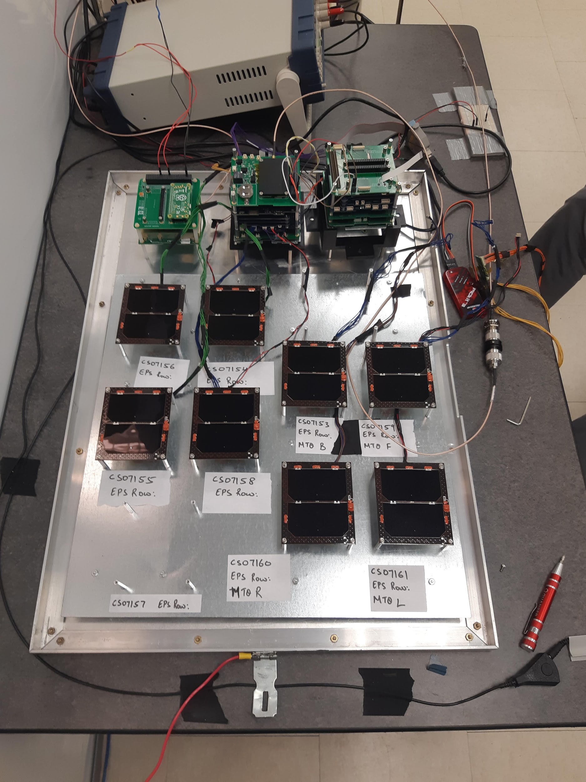

Figure 2.2.3.1.

# 3.0 STRUCTURAL COMPONENTS

## 3.1 EXTERIOR COMPONENTS AND HARDWARE

The Exterior Portion of the Cube satellite Is limited and must utilise all the area but also protect the interior components from being harmed by the exterior environment. The ESSENCE cube satellite Space Mind cassis is surrounded by 6061 aluminium alloy plates on all six faces mounted using M2.5 - 6mm stainless steel bolts.

### 3.1.1 CHASSIS

To guarantee fit and structure ESSENCE’s chassis is purchased from Space Mind, and features plunger switches and rail switches. The chassis is made from 6061 aluminium alloy and meets all the nanorack requirements.

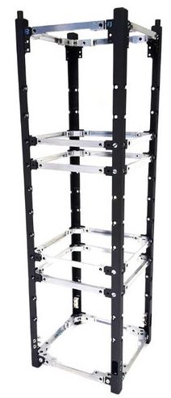

### 3.1.2 EXTERIOR PLATES

Exterior Top Plate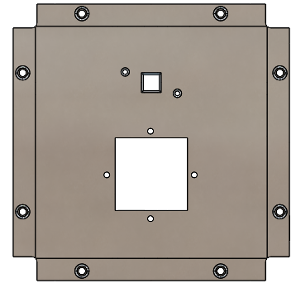

The Exterior Top plate is designed to secure to the top of the satellite and also secure the Gps antenna along with a fine sun sensor. All holes are countersunk in order to allow hardware to sit flush with the body. Since this face is flush it will allow this surface to fit in the nano racks required constraints.

Exterior Bottom Plate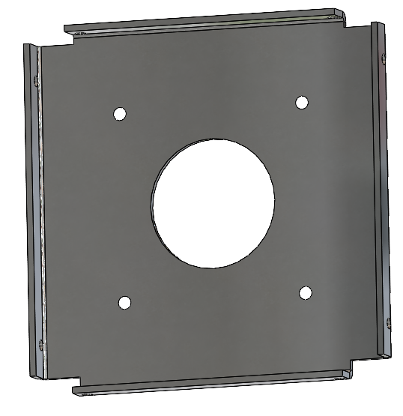

The Exterior Bottom plate is Designed to slip inside the bottom chassis structural bracket. This was to allow the NanoCom ANT430 to mount on the exterior and stay within the nanoracks constraints. The Face also features a camera lens hole with space around the lens to ventilate interior heat caused from the components operating. Four holes surround the camera lens hole which allow the camera to mount using standoffs. Lastly, the inside lip of the plate allows mounting screws to secure the plate to the chassis.

Exterior X/Y Plates

The Exterior X and Y Plates also feature counter sink holes in order for all hardware to sit flush to the surface. The 3 rectangular cutouts are to allow the solar panels back side headers access to the interior components. Also, the long vertical rectangle with the round corners is where the cube satellites burn wire deployment mechanism will sit.

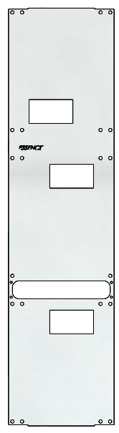

Exterior Burn Wire Plates

The Burn Wire plates cover the opening on the X/Y Plates. It will allow the Burn wire to access the antenna through the square opening on the right side of the plate. Also, the Positive Y-Face features an opening for the Fine sun sensor to have optimal view.

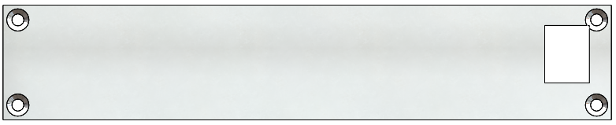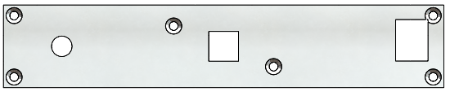

### 3.1.3 HARDWARE

In order to Fasten or secure many of the components the mechanical team has selected a variety of stainless steel hardware. Locktight solution will be applied to the threads of the bolts while performing final assembly. Thread-locking fluid is an adhesive, applied to the threads of fasteners to prevent corrosion, and the loosening of hardware/fasteners.

#### 

#### 3.1.3.1 Screws

|  |  |  |  |  |  |
| --- | --- | --- | --- | --- | --- |
| **Thread**  **Size** | **Length**  **(mm)** | **Thread Pitch**  **(mm)** | **Head Type** | **Drive Style** | **Quantity** |
| M2.5 | 6 | 0.45 | Flat | Hex | 60 |
| M1.6 | 10 | 0.35 | Flat | Slotted | 4 |
| M1.6 | 5 | 0.35 | Flat | Slotted | 16 |
| M3 | 5 | 0.5 | Flat | Hex | 4 |
| M2 | 10 | 0.4 | Flat | Hex | 4 |
| M2 | 8 |  | Socket | Hex | 2 |
| M2 | 6 |  | Socket | Hex | 2 |
| M2 | 3 |  | Socket | Hex | 8 |

#### 3.1.3.2 Nuts

|  |  |  |  |  |  |  |
| --- | --- | --- | --- | --- | --- | --- |
| **Thread**  **Size** | **width**  **(mm)** | **Height**  **(mm)** | **Thread Pitch**  **(mm)** | **Mass**  **(g)** | **Drive Style** | **Quantity** |
| M1.6 | 3.2 | 1.3 | 0.35  (Coarse) | NA | External Hex | 20 |
| M2 | 4 | 1.6 | 0.4  (Course) | NA | External Hex | 14 |

#### 3.1.3.3 Standoffs

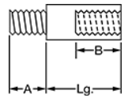

|  |  |  |  |  |  |  |
| --- | --- | --- | --- | --- | --- | --- |
| **Shape** | **Length**  **(mm)** | **Hex Size**  **(mm)** | **Thread A** | **Thread B** | **Mass**  **(g)** | **Quantity** |
| Hex | 11 | 4.5 | Size: M3  Pitch: 0.5mm Length: 5mm  Gender: Male | Size: M3  Pitch: 0.5mm Length: 6.4mm  Gender: Female | NA | 4 |
| Round Spacer | 5 | 4.5 | Open | Open | NA | 4 |

# 

# 4.0 SUB-ASSEMBLY

## 4.1 INTRO INTO SUB ASSEMBLY

The Essence mechanical team has developed sub assemblies which are members of a multipart structure in which the bill of materials of the main assembly will feature the sub assemblies. These sub assemblies consist of the Altitude and control housing unit, the magnetorquer, and the camera mounting assembly.

## 4.2 CAMERA MOUNTING ASSEMBLY

The Camera Mounting assembly will be the first sub assembly to be made and also will be the base of the main assembly. Four M3 - 11mm Standoffs are mounted to the front face of the camera body to ensure the distance the lens will protrude past the Z- Plate Face the distance needed for optimal view. The standoffs are then secured to the Z-Plate Face using the M3 -5mm sink head screws. This will all mount inside the Chassis Structural Bracket using the M3 4mm Screws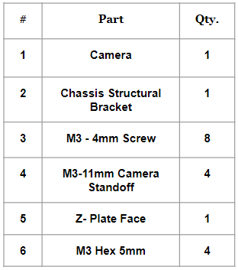

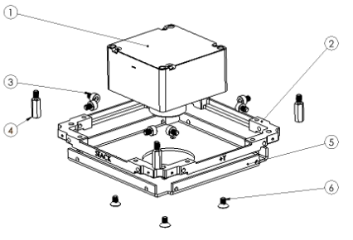

### 

### 4.3 ATTITUDE AND CONTROL HOUSING UNIT

The Attitude and control housing unit is one of the larger scaled sub assembly and so the mechanical team has decided to provide a detailed document of this unit along with this report. Reference: *Attitude Control System Report* for more information on this unit.

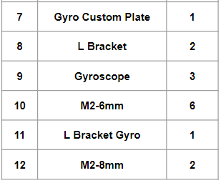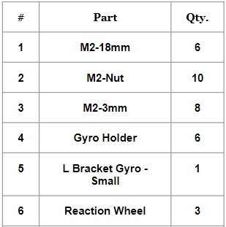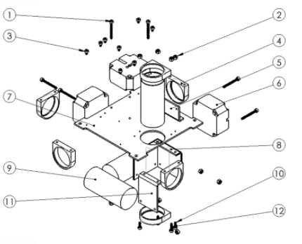

## 4.4 MAGNETORQUER

The Custom Magnetorquer was designed specifically for essence to fit within the satellite oriented horizontal to the z-axis without interference to the stack. This is why an opening has been made in order to bypass the magnetorçquer using pin stacks. Copper wire must be coiled around the 3D-printed structure before inserting the stack pins.

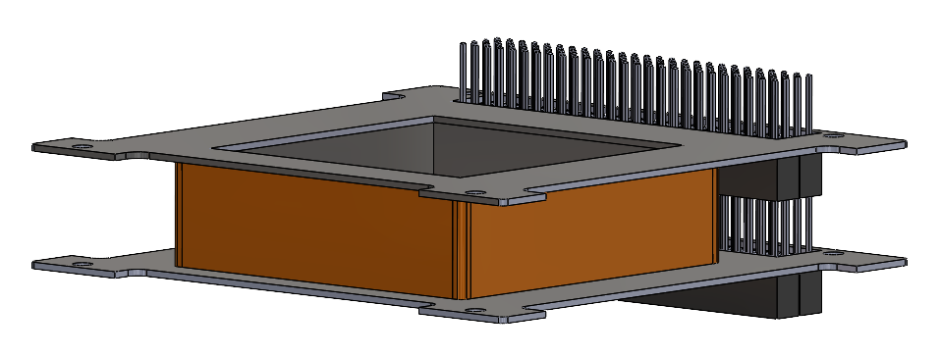

# 

## 4.5 ADCS UNIT SUBSYSTEM

ADCS is an Altitude Determination and Control System. It is a crucial subsystem of the Cube Satellite as it helps the satellite determine and change its attitude while orbiting. The ADCS subsystem consists of Sensors and estimators, Actuators, Controller, and Interface. The sensors will help determine the orientation of the satellite. Since there is no sensor that can directly measure the attitude of the satellite, several sensors are used to find the attitude of the satellite. Sensors require a frame of reference this is dependent on the sensor type for example, magnetometer measures the local magnetic field due to earth. After receiving the data from sensors the satellite may be required to change the orbit orientation to a specific direction; this is done by the Actuator by applying torque onto the satellite. Actuators will be used to move the satellite on the 3 axes (x,y,z). Some of the actuators used are magnetorquer and reaction wheel. Controller is used to collect and process the data. Controller will be used to calculate the required action necessary for a satellite to complete the mission. For example, it will calculate how much the actuator needs to rotate the satellite to the proper position. The controller will send the data to the On Board Computer which will then send the information to the individual actuators. Interface will be mainly responsible on sending and receiving data from and to microcontroller. It also controls the flow of power to the actuators in order for them to work properly.

More can be found on [<http://www.ece3sat.com/cubesatmodules/adcs/>] and [<https://www.aero.iitb.ac.in/satelliteWiki/index.php/Components_of_ADCS#Actuators>:]

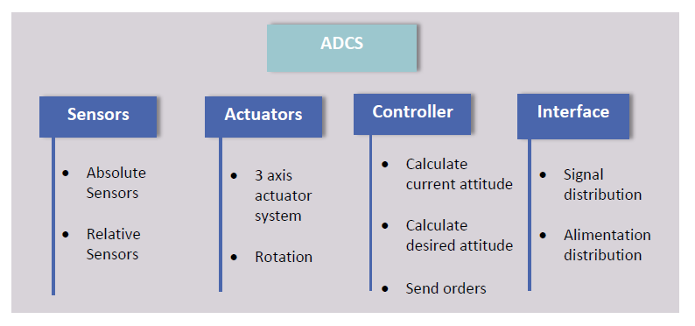

Some on ground simulations will be needed to be performed to make sure that the ADCS subsystem is functioning properly. It has to undergo several performance tests before being used. There are 3 important tests to undergo which are:

1- Software Simulation.

Mainly tests the controller vigorously using software languages like Python . The environmental models of the testing are created depending on the situation that is being tested.

2- On Board In Loop Simulation

In this testing the Controller is being tested on an actual microprocessor unlike the Software Simulation testing. Sensors and Environmental models are also simulated here (no actual sensors are being used).This test can be done mainly on LabView and Simulink programs.

3- Hardware In Loop Simulation. This is the final test which uses actual sensor data and the codes have to be impeded on a microprocessor. Thus, the sensors should be placed in an actual location to collect real life data and test whether the controller is processing the data properly and issuing correct information to the actuators to react to.

The ADCS subsystem has to pass these 3

# 5.0 MAIN ASSEMBLY

## 5.0 INTRO: MAIN-ASSEMBLY Essence consists of many components which unless assembled correctly could lead to problems. The mechanical team has designed an assembly plan that will aid in the process of the full assembly. Before proceeding to full assembly the sub assemblies should be complete first.

### 5.1.1 FIRST UNIT PROCEDURE.

The first Section or also known as the first unit is located at the bottom -Z-axis. This will --be the starting point of the full assembly and will take place mounted on 4 standoffs protruding from the assembly rig. These 4 standoffs will ensure that the assembly will be as stationary as possible and will prevent any sway in the structure.  
  
**STEP 1:** Mount the Camera sub assembly on top of the four rig standoffs with the lens of the camera facing downward (facing -Z-axis).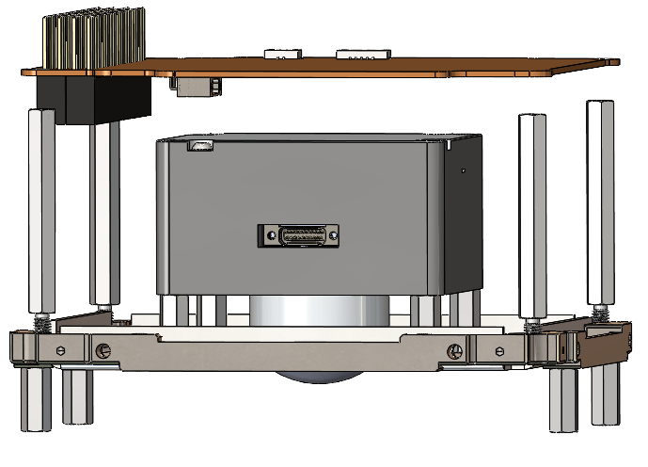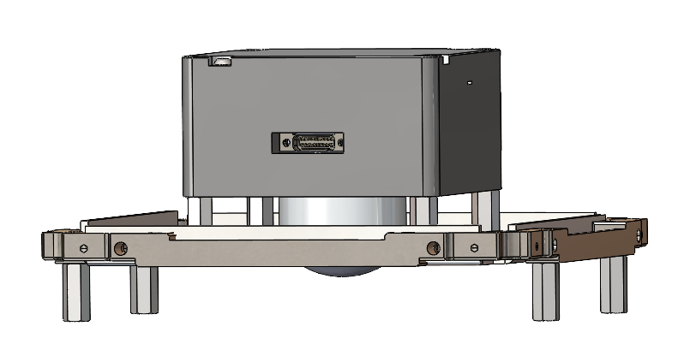

**STEP 2:** Next, thread four M3 32mm standoffs into each corner of the structure chassis bracket, then place the camera board on top making sure to place the stack on the +X-axis.

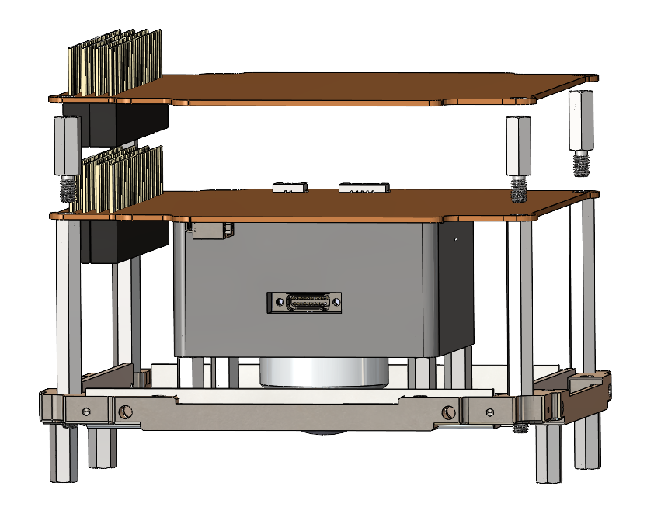

**STEP 3:** Thread four M3 10.5mm standoffs into the four previous standoffs in step 2. Then place the Proton detector board on top of these new standoffs.

**STEP 4:**  Place on Magnetorquer

**STEP 5:**  Install Chassis bracket

**STEP 6:** Insert Burn wire board/ daughter boards

### 

### 5.1.2 SECOND UNIT PROCEDURE

The Second Section, or also known as the Second Unit, is located at the middle of the -Z-axis. This will be the first Unit installed on top of the original Unit to complete the full assembly. The second Unit, much like the first, will take place mounted on four standoffs protruding from the assembly rig. This Unit will contain the essential electrical power system and mission systems payload components.

**STEP 1:** Secure one chassis structure bracket to the four standoffs following Board 6.

**STEP 2:** Fasten four 3M “length” standoffs to the chassis bracket in step 1, and then place the power distribution unit on top.

**STEP 3:** Next, slide the BPX battery and the long-range NanoCom AX100 radio on top of the power distribution unit on top of the Chassis Structural Bracket. Then place a second Chassis Structural bracket on top of those components, ensuring it's facing the +X-axis.

**STEP 4:** Insert the thirty-minute timer board above the second Chassis Structural bracket.

### 5.1.3 THIRD UNIT PROCEDURE

The third Section, or also known as the Third Unit, is located at the top of the -Z-axis. This will be the second Unit installed on top of the first original Unit to complete the full assembly. The third Unit, much like the first and the second, will take place mounted on four standoffs protruding from the assembly rig. This Unit will contain essential altitude control and communication control components.

**STEP 1:** Place the Attitude and Control Board on top of the Chassis Structural Bracket and in between the four rig standoffs

**STEP 2:** Slide the Attitude and Control Housing Unit, containing the reaction wheels and the gyroscopes between the four rig standoffs and on top of the Attitude and Control Board. Then place a second Chassis Structural bracket on top of those components, ensuring it's facing the +X-axis.

**STEP 3:** lastly, install the GPS Antenna and Fine Sun Sensor over top of the +Z Body Panel.

### 5.1.4 DEPLOYABLES AND MECHANISMS

This section of the paper deals with the deployable nanosatellite mechanisms like the four antennas strapped along the sides of the Cube-Sat and the methods used to deploy them like the burn wire release mechanism and the plunger rail switches.

#### 5.1.4.1 BURN WIRE MECHANISM

The Burn Wire mechanism is a standard efficient method of Cube-Sat appendage deployment. The wire is made from material in the nichrome family of alloys that, when heated up, cuts through a fishing line which releases the antenna. When cut, the satellite appendages are allowed to actuate. The ESSENCE team will use a burn wire to deploy the antennas, similar to previous mission descent. The burn wire can be seen below.

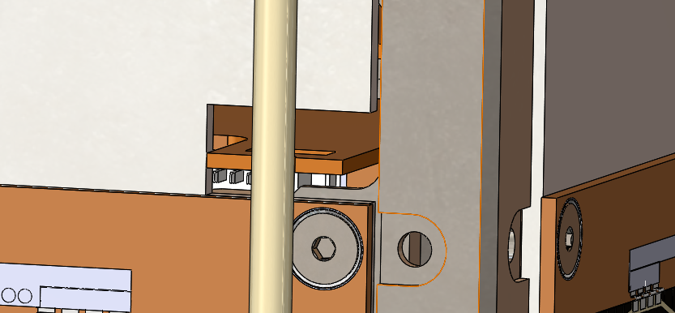

#### 5.1.4.2 PLUNGER AND RAIL SWITCHES AND RBF PIN The plunger and rail switch system works with the RBF pin and when all systems are activated, the 30 minute timer board will start counting down. This happens when the satellite leaves the nanorack and all pressure is released from holding these switches in the downward position. Multiple switches and plungers are implemented so that in the case issues arise there is a backup system.

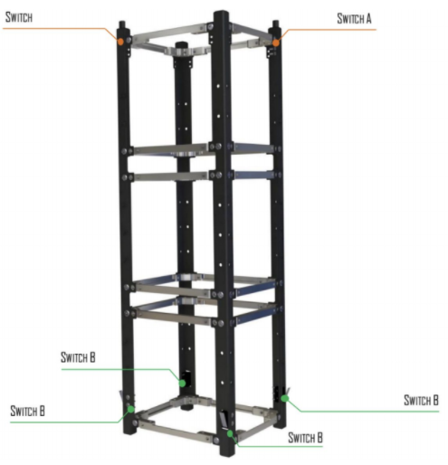

#### 

#### 

#### 5.1.5 HARNESSES AND CONNECTORS

#### Throughout the ESSENCE satillite many Harnesses and connectors are required for operation. First the Electrical team provided the proper information about surface mounted headers and harness male connectors. Next, the mechanical team then modeled the custom PCB layout to optimize harness length and routing. Once the headers were placed the wires could then be modeled and routed through the satellite. Lastly, harnesses were flattened to get the length required to run the route. The figure below shows a 3D model of a cable, and the lengths associated with each wire in the cable.

#### 

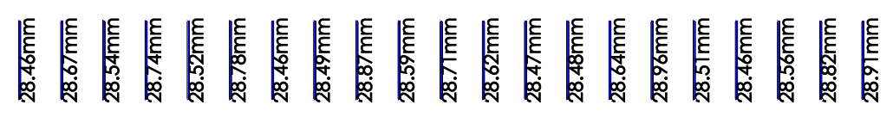

These Wire Segments give us a close approximation to the lengths needed in the actual Satellite when assembling. Next, More thorough drawings can be made for each cable, wire and harness needed in the build.

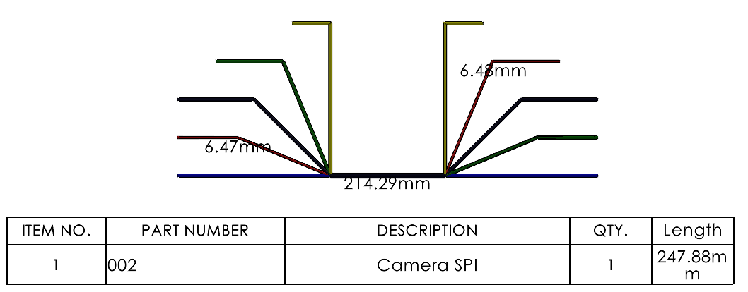

|  |  |  |  |  |  |  |
| --- | --- | --- | --- | --- | --- | --- |
| ITEM NO. | PART NUMBER | DESCRIPTION | QTY. of wires | LENGTH | Wire thickness | Model number |
| 1 | 017 | Gyroscope 3- Gyro and RXN wheel board (custom PCB) | 5 wires inside cable | 89.69mm for each of the wires |  |  |
| 2 | 018 | Gyroscope 1 - Gyro and RXN wheel board (custom PCB) | 5 wires inside cable | 54.27 mm for each of the wires |  |  |
| 3 | 019 | Gyroscope 2 - Gyro and RXN wheel board (custom PCB) | 5 wires inside cable | 31.25mm for each of the wires |  |  |
| 4 | 020 | Reaction wheel 1- Gyro and RXN wheel board (custom PCB) | 4 wires inside cable | 72.64mm  for each of the wires |  |  |
| 5 | 021 | Reaction wheel 2- Gyro and RXN wheel board (custom PCB) | 4 wires inside cable | 46.18 mm for each of the wires |  |  |
| 6 | 022 | Reaction wheel 3- Gyro and RXN wheel board (custom PCB) | 4 wires inside cable | 13.48mm for each of the wires |  |  |
| 7 | 023 | Ant bracket-Nanocom AX100 | 1 wires | 147.23mm |  |  |
| 8 | 025 | Gps antenna-Gps receiver | 1 wire | 90.98mm |  |  |
| 9 | 030 | FFS( near antenna)- Timer board | 4 wires inside cable | 82.31mm for each of the wires |  |  |
| 10 | 031 | OBC Board- custom PCB board (above camera, under magnetorquer) | 5 wires inside cable | 115.00mm for each of the wires |  |  |
| 11 | 034 | FFS(on xy side)- Nanodoc ADCS-2 | 4 wires inside cable | 18.30mm for each of the wires |  |  |

# 6.0 THERMAL ANALYSIS

## 6.1 THERMAL THEORY

The purpose of a thermal analysis is to simulate the typical environment that the satellite will operate in. Typical modes of heat transfer are radiation, conduction, and convection. The analysis covers a hot case and a cold case which are the extremes of the environment the satellite will operate in. The satellite will be under direct solar radiation received from the sun, the albedo radiation caused from the reflection of the planet, and the Earth IR. Along with the space environment, the satellite will also be producing its own operational temperatures as the satellite uses different components to complete tasks.

## 6.2 Heat Transfer Modes

There are several modes of heat transfer to consider when performing an analysis in the space environment of low Earth orbit. It is important for these modes to be identified and have a high level of knowledge of these forms of heat transfer. Thermal energy will have an effect on the overall structure and operations of the satellite. These modes include radiation, convection, and conduction.

### 6.2.1 Radiation

Radiation is a form of electromagnetic waves which emit energy causing changes to the atoms and molecules it interacts with. Radiation is in the units W/m^2 and is the flow of energy in an area. It can be represented by Stefan-Boltzmann’s law:

$q_{e}=σT^{4}$

$$T=Temperature$$

$$σ=Boltzmann constant$$

$$q=Heat energy transferred$$

From a surface the rate of emission in watts can be seen below:

$$Q_{e}=εσAT^{4}$$

$$Q=Rate of heat flux$$

$$ε=Emissivity$$

$$σ=Boltzmann constant$$

$$A=Area of surface$$

$$T=Temperature$$

The satellite will see the impact of radiation from not only the sun, but also the reflection of the Earth's albedo.

### 6.2.2 Convection

Convection is the heat transferred from a surface and a median which is a result from a fluid moving due to a pressure change, forced convection, or a free convection. The rate at which heat is transferred from a surface to a fluid is proportional to the temperature difference of the surface and the fluid. This is denoted by Newton’s law of cooling states and is measured in units W/m^2-k:

$Q=hA(T_{s}-T_{∞})$

$$Q=heat Convected$$

$$A=Area of surface$$

$$T=Temperature$$

$$h=Heat transfer coefficient$$

The cube satellite will undergo convection not only during operations in low Earth orbit, but also during ground operations and during launch. The components in the satellite will heat up and cool down during the lifespan of the mission which will result in temperature change throughout the structure.

### 6.2.3 Conduction

Conduction is a transfer of energy between particles which are less energetic. The temperature gradient is what causes conduction and is known as Fourier’s Law of heat conduction:

$$Q=-kA\frac{dT}{dx}$$

$$Q=heat Conducted$$

$$A=Area of surface$$

$$\frac{dT}{dx}=Temperature gradient$$

$$k=Thermal conductivity$$

Throughout the lifetime of the satellite it will be conducting heat through normal operations of each component which will result in the convected heat within the satellite.

## 6.3 Environment Low Earth Orbit

A spacecraft in LEO will receive electromagnetic radiation from three primary external sources. The largest source is the direct solar flux. The mean value of this solar flux at the mean Sun-Earth distance is called the *solar constant*. It is not really a constant but varies by about 3.4% during each year because of the slightly elliptical orbit of the Earth about the Sun. In addition the amount of radiation emitted by the Sun varies slightly (by about 0.1%) throughout the 11-years solar cycle.

The fraction of incident sunlight that is reflected off a planet is termed *albedo*. For an orbiting spacecraft the albedo value depends mainly on the sunlit part of the Earth which it can see. Albedo radiation has approximately the same spectral distribution as the Sun. Albedo is highly variable across the globe and depends on surface properties and cloud cover. It also depends on the solar zenith angle.

The third source is the Earth's infrared radiation. The Earth-emitted thermal radiation has a spectrum of a black body with a characteristic average temperature of 288 K. The Earth infrared radiation also varies across the globe but less than the albedo. It also shows a diurnal variation which is small over the ocean but can amount to 20% for desert areas. [7]

### 6.3.1 Solar Radiation

Energetic particles and electromagnetic radiation (EM) from solar events and galactic cosmic rays can bombard and interact with satellites’ exposed surfaces, and sometimes possess enough energy to penetrate their surface. Among other known effects, the scenario can cause accelerated orbit decay due to atmospheric drag, sporadic and unexplainable errors in functions of sensitive parts, degradation of critical properties of structural materials, jeopardy of flight worthiness, transient and terminal health hazard to both onboard passengers and astronauts, and sometimes a catastrophic failure that can abruptly end satellite mission.

The energetic particles and electromagnetic radiation from these processes form the near-Earth radiation environment and can be divided into (i) trapped radiation environment and (ii) transient radiation environments. The charged particles that are trapped or confined by the Earth’s magnetic field to certain regions in space such as the Van Allen belts form the trapped radiation environment. The transient particles environment consists of energetic particles from solar events, and galactic cosmic radiation that exist in the interplanetary space regions and in the near-Earth regions. Satellites and other space application systems are vulnerable to both trapped and transient energetic particles since they are basically designed to operate in the space plasma environment. The particles can bombard and interact with satellites’ surfaces, and sometimes posses enough energy to penetrate their exposed surfaces with possible access to their electrical, electronic and electrochemical components (EEECs). This scenario can induce sporadic and unexplainable errors in sensitive parts of spacecrafts, degrade the critical properties of their structural materials, jeopardize the flight worthiness of spacecrafts, constitute transient and terminal health hazard to both onboard passengers and astronauts, and even lead to total failure that can end the mission of affected spacecrafts. [6]

### 6.3.2 Albedo Radiation

It is an extremely complex phenomenon which shows relevant spatial and temporal variations. Albedo depends upon the reflectivity of the illuminated surface of the Earth that is visible to the spacecraft, the solar angle, and the position of the spacecraft in space. Moreover, it depends on seasonal variations and geographical longitude and latitude of the Earth surface that is illuminated by the Sun and seen by the satellite. (Lot more info can be found at: [7].

### 6.3.3 Earth IR

Earth scientists study infrared as the **thermal emission (or heat)** from our planet. As incident solar radiation hits Earth, some of this energy is absorbed by the atmosphere and the surface, thereby warming the planet. This heat is emitted from Earth in the form of infrared radiation. The Earth-emitted thermal radiation has a spectrum of a black body with a characteristic average temperature of 288 K. The Earth infrared radiation also varies across the globe but less than the albedo. It also shows a diurnal variation which is small over the ocean but can amount to 20% for desert areas.

## 6.4 Component Operational Temperature

Thermal analysis is an essential element in the design and integration processes of a Cube-Sat. The need for a thermal analysis comes from the fact that any environmental temperature stress outside of the normal operational or survivability range of any of the components could lead to the Cube-Sat becoming inoperable. Originally, during the data collecting phase of the design process, the operational and survivable temperature ranges were collected from the component manufacturers. Once these ranges were collected, a Thermal analysis was conducted to be in line with CSA provided guidelines using simulation software to ensure the whole Cube-Sat did not exceed its operational temperature range.

|  |  |
| --- | --- |
| Component | Operational Temperature (°C) |
| COMMUNICATION SUBSYSTEM | |
| OEM719 GNSS Receiver | -40 to +85 |
| UHF/VHF Rx Antenna | -85 to +40 |
| Gomspace NanoCom AX100 | -30 to +85 |
| DATA HANDLING SUBSYSTEM | |
| OBC- NanoMind A3200 | -40 to +105 |
| Customized PCB | -40 to +105 |
| ELECTRICAL POWER SUBSYSTEM | |
| GOMspace p110A solar panel | -40 to +85 |
| GOMSpace NanoPower P60 Dock | -35 to +85 |
| GOMSpace NanoPower P60 PDU-200 | -35 to +85 |
| GOMSpace NanoPower P60 ACU-200 | -35 to +85 |
| Nanopower BPX battery | -40 to +85 |
| ATTITUDE DETERMINATION & CONTROL SUBSYSTEM | |
| Sinclair reaction wheels | -20 to +70 |
| Reaction Wheels Adapter Board | -40 to +85 |
| Fizoptika Optic Gyroscope VG091 | -40 to +70 |
| gomspace fine sun sensor | -40 to +100 |
| Gomspace Nano Torque GST-600 | -40 to +85 |
| STRUCTURE & MECHANICAL SUBSYSTEM | |
| Space Mind Chassis | -35 to +80 |
| Side panels +-Z | -35 to +80 |
| Side panels +-xy | -35 to +80 |
| Optical gyro adapter board (uncertain) | -40 to +85 |
| Thermal coatings and paints | -70 to +70 |
| MISSION SYSTEMS PAYLOADS | |
| Fisheye Wide-Angle Camera | -20 to +40 |
| Proton Detector | N/A |
| Gomspace ADCS-3 | -40 to +85 |
| Gomspace DMC-3 | -40 to +85 |
| TW1320 GPS Antenna | -40 to +85 |

## 6.4 PANDEMIC LIMITATIONS

## 

# 7.0 VIBRATION ANALYSIS

## 7.1 PURPOSE OF VIBRATION TESTING

## 7.2 ANALYSIS ASSUMPTIONS

# 8.0 INFORMATIONAL METRICS

## 8.1 MASS BUDGET

The mass properties recorded in the mass and volume budget reference the total mass, the maximum mass and the mass uncertainty. This is for both the individual parts of the Cubesat and the entire unit. Mass properties also identified are the moments of inertia (MOIs), and products of inertia (POI) center of gravity (CG) for every axis. This information was obtained from each and every component supplier and from team calculations.

|  |  |  |  |  |
| --- | --- | --- | --- | --- |
| **SubSystem** | **Component** | **Quantity** | **Mass (g)** | **Mass Uncertainty 15% (g)** |
| **Communication** | OEM615 GNSS Receiver | 1 | 24 | 0.24 |
| Gomspace NanoCom AX100 | 1 | 24.5 | 0.25 |
| nanocom ANT430 | 1 | 30 | 4.5 |
| **Data Handling** | OBC- NanoMind A3200 | 1 | 24 | 0.24 |
| Customized PCB (Uncertain dimensions) | 4 | 200 | 2 |
| **Electrical Power Subsystem** | Burn Wire PCB | 4 | 0.392 | 0.06 |
| GOMspace p110A solar panel | 12 | 312 | 3.12 |
| GOMSpace NanoPower P60 Dock | 1 | 80 | 0.8 |
| GOMSpace NanoPower P60 PDU-200 | 1 | 57 | 0.57 |
| GOMSpace NanoPower P60 ACU-200 | 1 | 54 | 0.54 |
| Nanopower BPX battery | 1 | 500 | 5 |
| Wires | 0 | 0 | 0 |
| **Altitude and determination Control system** | Sinclair reaction wheels | 3 | 142.5 | 1.43 |
| Fizoptika Optic Gyroscope VG091 | 3 | 90 | 0.9 |
| gomspace fine sun sensor | 2 | 4.4 | 0.04 |
| Customized magnetorquer | 1 | 35.3 | 5.3 |
| **Structure and Mechanical Subsystem** | Space Mind Chassis | 1 | 230 | 2.3 |
| gyro/RW mounting plate | 1 | 28.377 | 4.26 |
| Gyro holding ring | 6 | 41.4 | 6.21 |
| reaction wheel L-bracket | 2 | 3.2 | 0.48 |
| gyro L-bracket(small) | 1 | 7.14 | 1.07 |
| gyro L-bracket(Large) | 1 | 12.168 | 1.83 |
| burnwire L bracket | 4 | 5.04 | 0.76 |
| burn wire plate with hole | 1 | 2.5 | 0.38 |
| burn wire plate | 3 | 7.83 | 1.17 |
| Side panels +Z | 1 | 35.51 | 5.33 |
| side panels -z | 1 | 31.83 | 4.77 |
| Side panels +-xy | 4 | 388.8 | 58.32 |
| Wiring harness(uncertain) | 1 | 0 | 0 |
| Thermal coatings and paints (uncertain) | 1 | 0 | 0 |
| **Hardware** | M2 nuts | 7(will be more) | 1.75 | 0.02 |
| M2 18mm | 6 | 3.276 | 0.03 |
| M2 3mm | 8 | 1.752 | 0.02 |
| M2 6mm | 2 | 0.554 | 0.01 |
| M2 8mm | 2 | 0.63 | 0.01 |
| M2 1.6 nuts | 4 | 0.302 | 0 |
| M 2.5 6mm | 58 | 16.008 | 0.16 |
| M1.6 10mm | 4 | 0.5264 | 0.01 |
| M1.6 4mm | 16 | 0.96 | 0.01 |
| M3 11mm standoff | 4 | 5.84 | 0.06 |
| M3 5mm | 4 | 1.436 | 0.01 |
| M3 full length standoff | 4 | 91.8 | 0.92 |
| M3 4mm | 8 | 5.28 | 0.05 |
| MISSION SYSTEMS PAYLOADS |  |  | 0 |
| **Mission Systems Payloads** | Fisheye Wide-Angle Camera | 1 | 135 | 1.35 |
| Proton Detector(uncertain) | 1 | 50 | 0.5 |
| Gomspace ADCS-3 | 1 | 60 | 0.6 |
| Gomspace DMC-3 | 1 | 51 | 0.51 |
| TW1320 GPS Antenna | 1 | 50 | 0.5 |
| **TOTAL** |  |  | **2848.0014** | **427.2** |

## 

## 8.2 VOLUME BUDGET

The volume properties recorded in the mass and volume budget reference the total volume, the maximum volume and the mass volume. This is for both the individual parts of the Cubesat and the entire unit.This information was obtained from each and every component supplier and from team calculations.

|  |  |  |  |  |
| --- | --- | --- | --- | --- |
| **SubSystem** | **Component** | **Quantity** | **Volume**  **(mm^3)** | **Volume Uncertainty (mm^3)** |
| **Communication** | OEM615 GNSS Receiver | 1 | 23468.1 | 234.68 |
| Gomspace NanoCom AX100 | 1 | 8329.64 | 83.3 |
| nanocom ANT430 | 1 | 5890 | 58.9 |
| **Data Handling** | OBC- NanoMind A3200 | 1 | 8926.26 | 89.26 |
| Customized PCB (Uncertain dimensions) | 4 | 65557 | 9833.55 |
| **Electrical Power Subsystem** | Burn Wire PCB | 4 | 62.62 | 9.39 |
| GOMspace p110A solar panel | 12 | 121502 | 1215.02 |
| GOMSpace NanoPower P60 Dock | 1 | 49908.18 | 499.08 |
| GOMSpace NanoPower P60 PDU-200 | 1 |
| GOMSpace NanoPower P60 ACU-200 | 1 |
| Nanopower BPX battery | 1 | 173501.59 | 1735.02 |
| Wires | 0 | N/A | N/A |
| **Altitude and determination Control system** | Sinclair reaction wheels | 3 | 17706.31 | 177.06 |
| Fizoptika Optic Gyroscope VG091 | 3 | 69957.27 | 699.57 |
| gomspace fine sun sensor | 2 | 1560.34 | 234.05 |
| Customized magnetorquer | 1 | 33940.17 | 5091.03 |
| **Structure and Mechanical Subsystem** | Space Mind Chassis | 1 | 93549.24 | 935.49 |
| gyro/RW mounting plate | 1 | 10509.93 | 1576.49 |
| Gyro holding ring | 6 | 5174.22 | 776.13 |
| reaction wheel L-bracket | 2 | 2003.99 | 300.6 |
| gyro L-bracket(small) | 1 | 892.2 | 133.83 |
| gyro L-bracket(Large) | 1 | 1521.65 | 228.25 |
| burnwire L bracket | 4 | 630 | 94.5 |
| burn wire plate with hole | 1 | 926.71 | 139.01 |
| burn wire plate | 3 | 2900.43 | 435.06 |
| Side panels +Z | 1 | 13154.05 | 1973.11 |
| side panels -z | 1 | 11791.41 | 1768.71 |
| Side panels +-xy | 4 | 144021.28 | 21603.19 |
| Wiring harness(uncertain) | 1 | N/A | N/A |
| Thermal coatings and paints (uncertain) | 1 | N/A | N/A |
| **Hardware** | M2 nuts | 7(will be more) | 218.89 | 2.19 |
| M2 18mm | 6 | 409.5 | 4.1 |
| M2 3mm | 8 | 218.96 | 2.19 |
| M2 6mm | 2 | 69.16 | 0.69 |
| M2 8mm | 2 | 78.78 | 0.79 |
| M2 1.6 nuts | 4 | 37.72 | 0.38 |
| M 2.5 6mm | 58 | 1999.84 | 20 |
| M1.6 10mm | 4 | 65.8 | 0.66 |
| M1.6 4mm | 16 | 120.96 | 1.21 |
| M3 11mm standoff | 4 | 730.68 | 7.31 |
| M3 5mm | 4 | 179.32 | 1.79 |
| M3 full length standoff | 4 | 11473 | 114.73 |
| M3 4mm | 8 | 663.68 | 6.64 |
| **Mission Systems Payloads** | Fisheye Wide-Angle Camera | 1 | 69718.68 | 697.19 |
| Proton Detector(uncertain) | 1 | 0 | 0 |
| Gomspace ADCS-3 | 1 | 16389.25 | 163.89 |
| Gomspace DMC-3 | 1 | 18440.86 | 184.41 |
| TW1320 GPS Antenna | 1 | 6980.13 | 69.8 |
| **TOTAL** |  |  | **995179** | **149276.97** |

# 

# 

# 

# 

# 

# 9.0 MECHANICAL GROUND SUPPORT EQUIPMENT

## 9.1 STOWAGE CASE

Like other satellite manufacturing projects, the essence CubeSat project requires a physical transport mechanism to transport the unit to and from given destinations. The equipment meant to serve this function is denoted by the term ground support equipment (GSE). The mechanical aspects of the ground support equipment are (MGSE). A part of the (MGSE), the stowage case, is the primary unit designed for storage, protection and transportation of the CubeSat. For the ESSENCE project, to ensure that our CubeSat is safe during travel, the team has chosen to rent a Pelican stowage case from the Canadian space agency. Further protections to ensure the Cube-Sat's safety and security include a Lens Cover for the satellite camera and covers on the solar panel to protect it from damage.

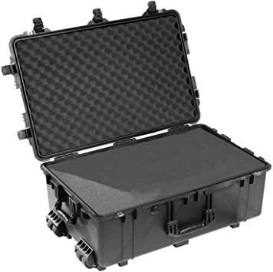

(Figure 9.1)

## 9.2 PROGRAMING AND POWER HARNESS

The mechanical ground support equipment has been designed to include several electrical aspects in its structure to work alongside the MGSE's physical characteristics and the onboard electronics of the Cube-Sat. A central component of the MGSE's electrical elements takes the form of the Cube-Sat's wire harness. The CubeSat's wire harness is a particular formation of electrical cables and wires with the purpose of transmitting signals and electrical power around the Cube-Sat. The wire harness features two ports on top of the z plus axis and bound by two wires; the wire harness plugs into the top of the satellite, intending to program and debug the Cube-Sat.

## 9.3 TESTING RIG

To ensure project success, vibration testing must be conducted to test the Cube-Sat's durability and resilience in its operational environment. Commonly, in Cube-Sat design and development, vibration testing is performed by a testing rig. The testing rig is a piece of machinery that is primarily used to record the capability and performance of components in the Cube-Sat. All data that is collected from this procedure will be taken from the vibration testing that will occur at the DFL through the CSA. The CubeSat will be tested using the following random vibration test profile obtained from the NanoRacks Interface Control Document. The Cube-Sat and the stowage

(Figure 7.3)

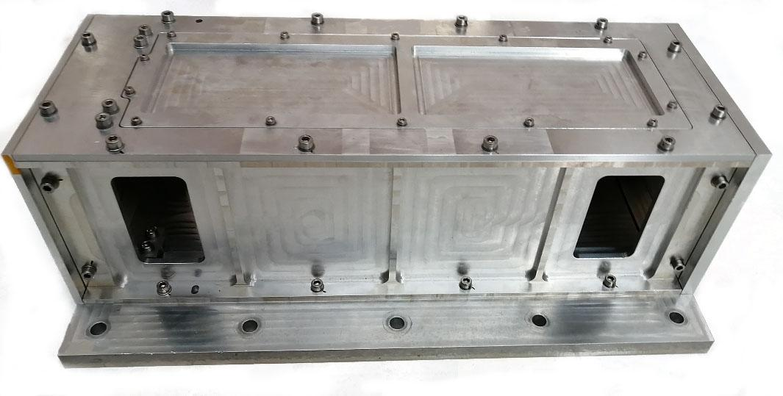

# 

# 

# 

# 

# 

# 

# 10.0 REFERENCES AND CONCLUSION

## 10.1 ACKNOWLEDGEMENTS

This report was led by Matthew Olver and written by the Mechanical team for the purpose of placing a plan for manufacturing and integrating the ESSENCE CubeSat. This report was supervised by the Mechanical Team Lead Jordan Birely and The Head of Project Professor George Zhu.

## 10.2 LIST OF FIGURES

### 10.2.1 Body Plates

*Z+ plate drawing*

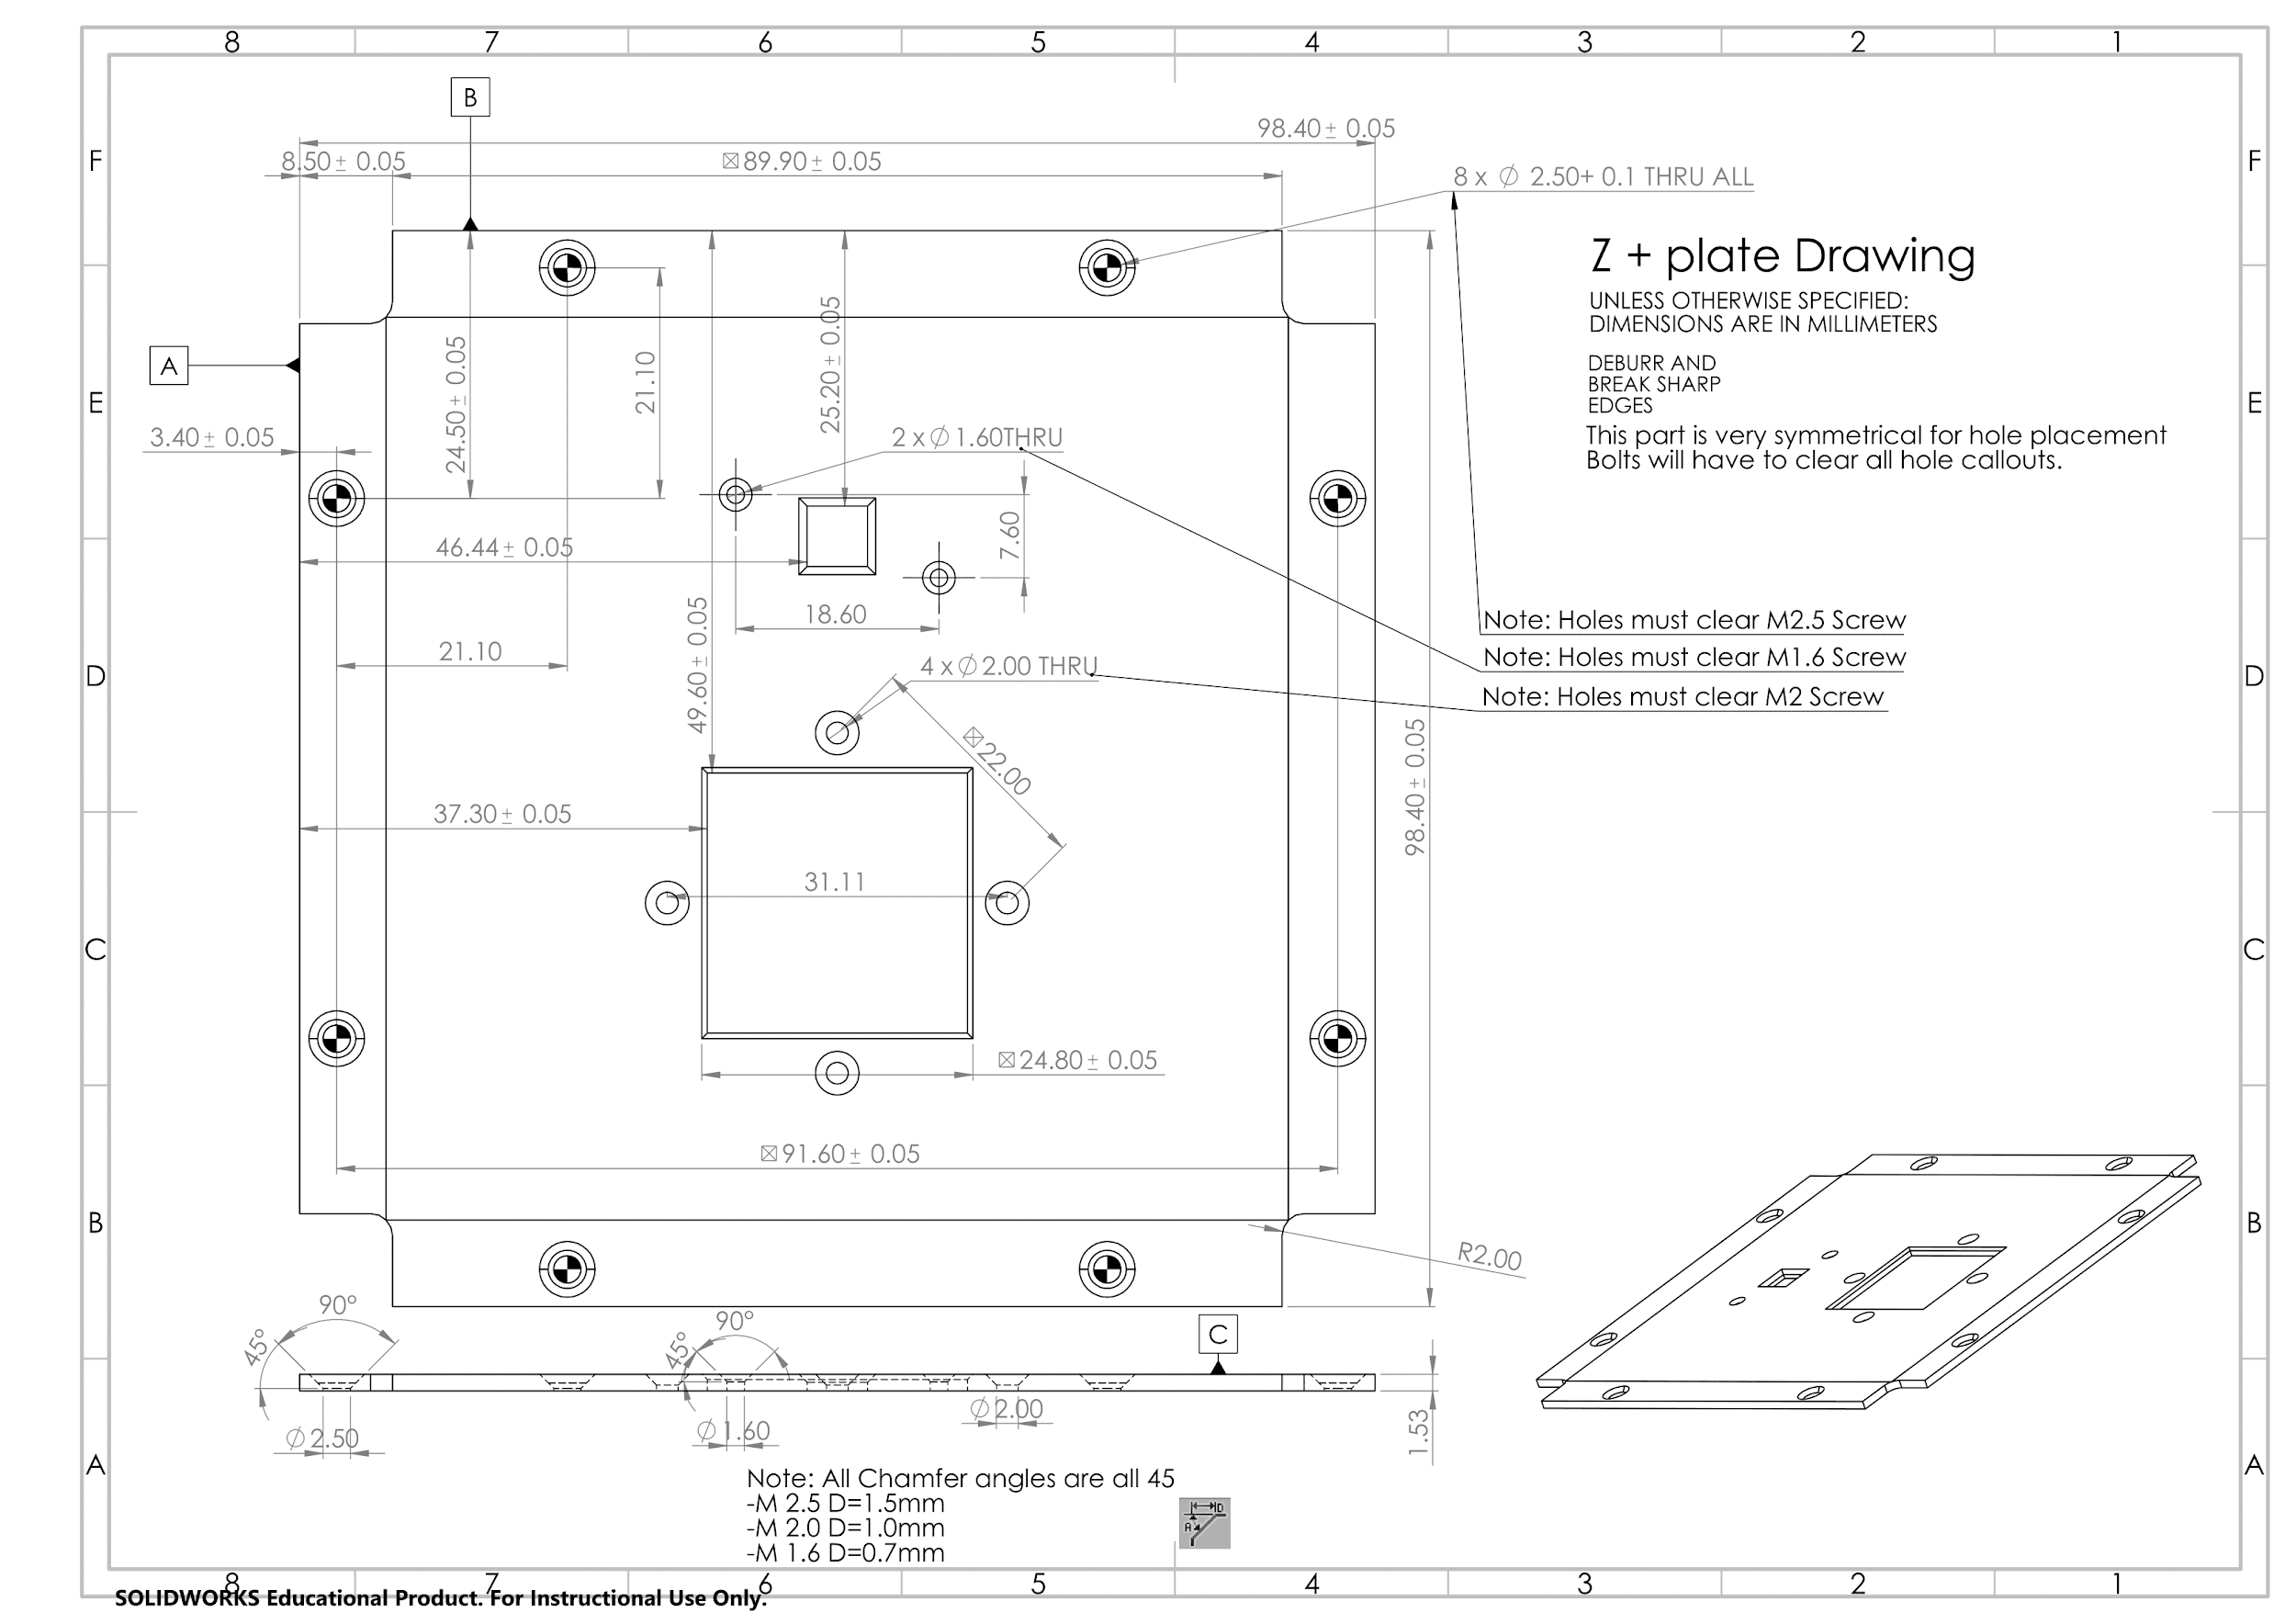

*Z- plate drawing*

*X-Y Side Plates*

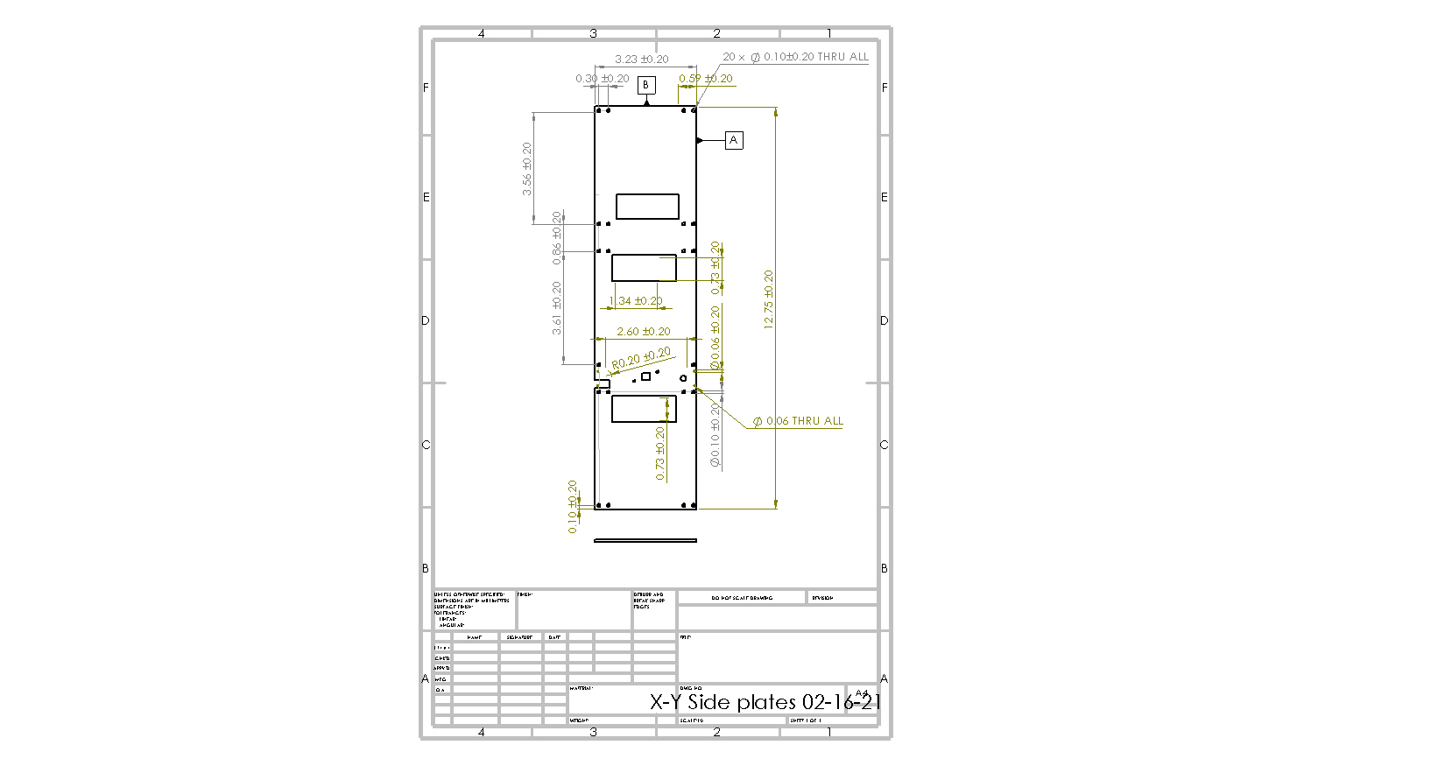

### 10.2.2 Chassis

*Chassis drawing*

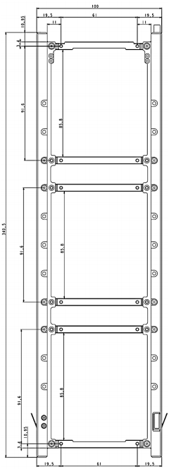

### 10.2.3 Components

*Camera Drawing*

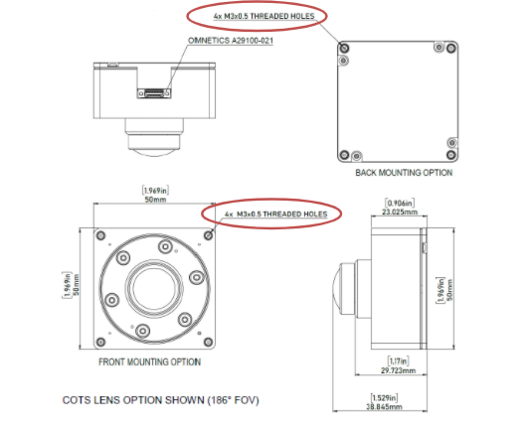

*GPS Antenna*

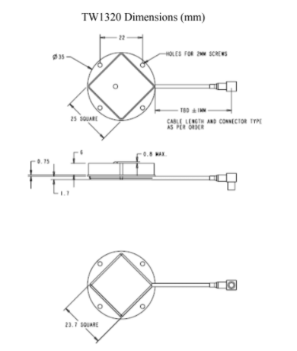

*GOMspace NanoCom AX100*

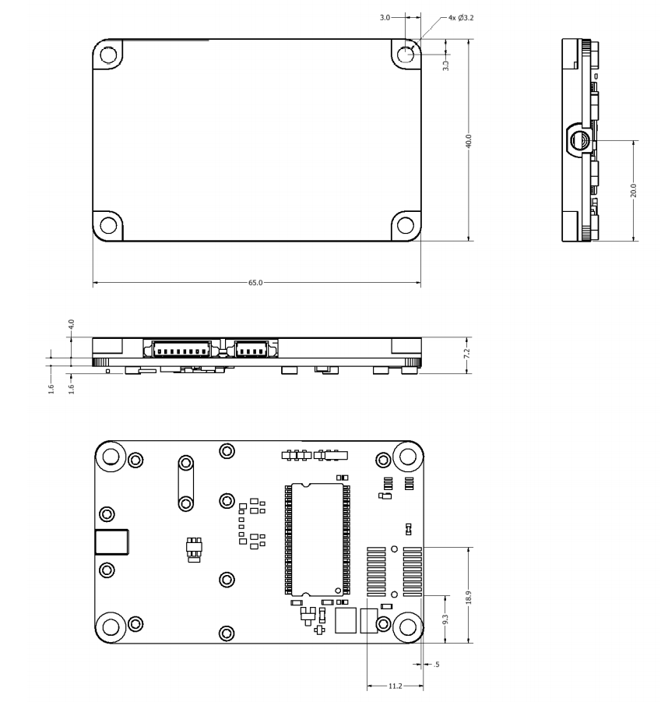

*NanoMind A3200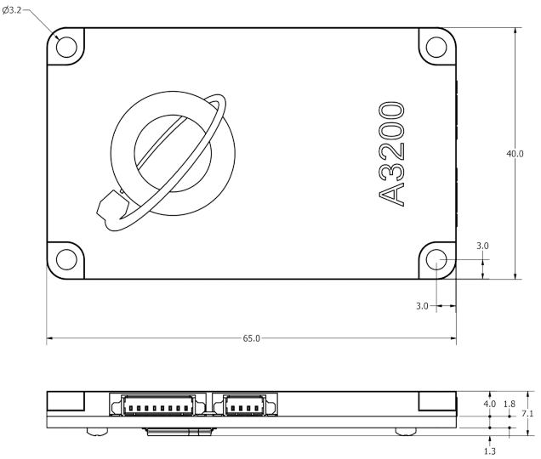*

*NanoPower P60 Dock*

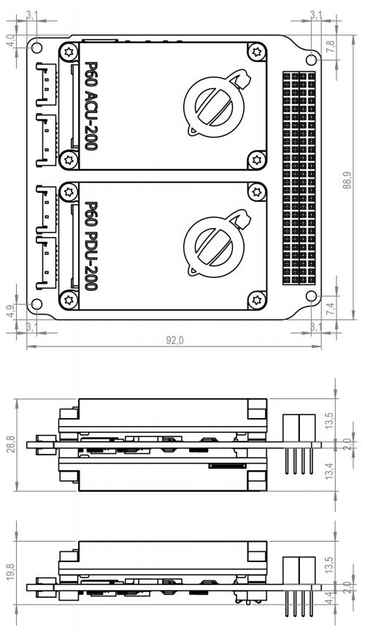

### 10.2.4 Connectors

*Stack Connector*

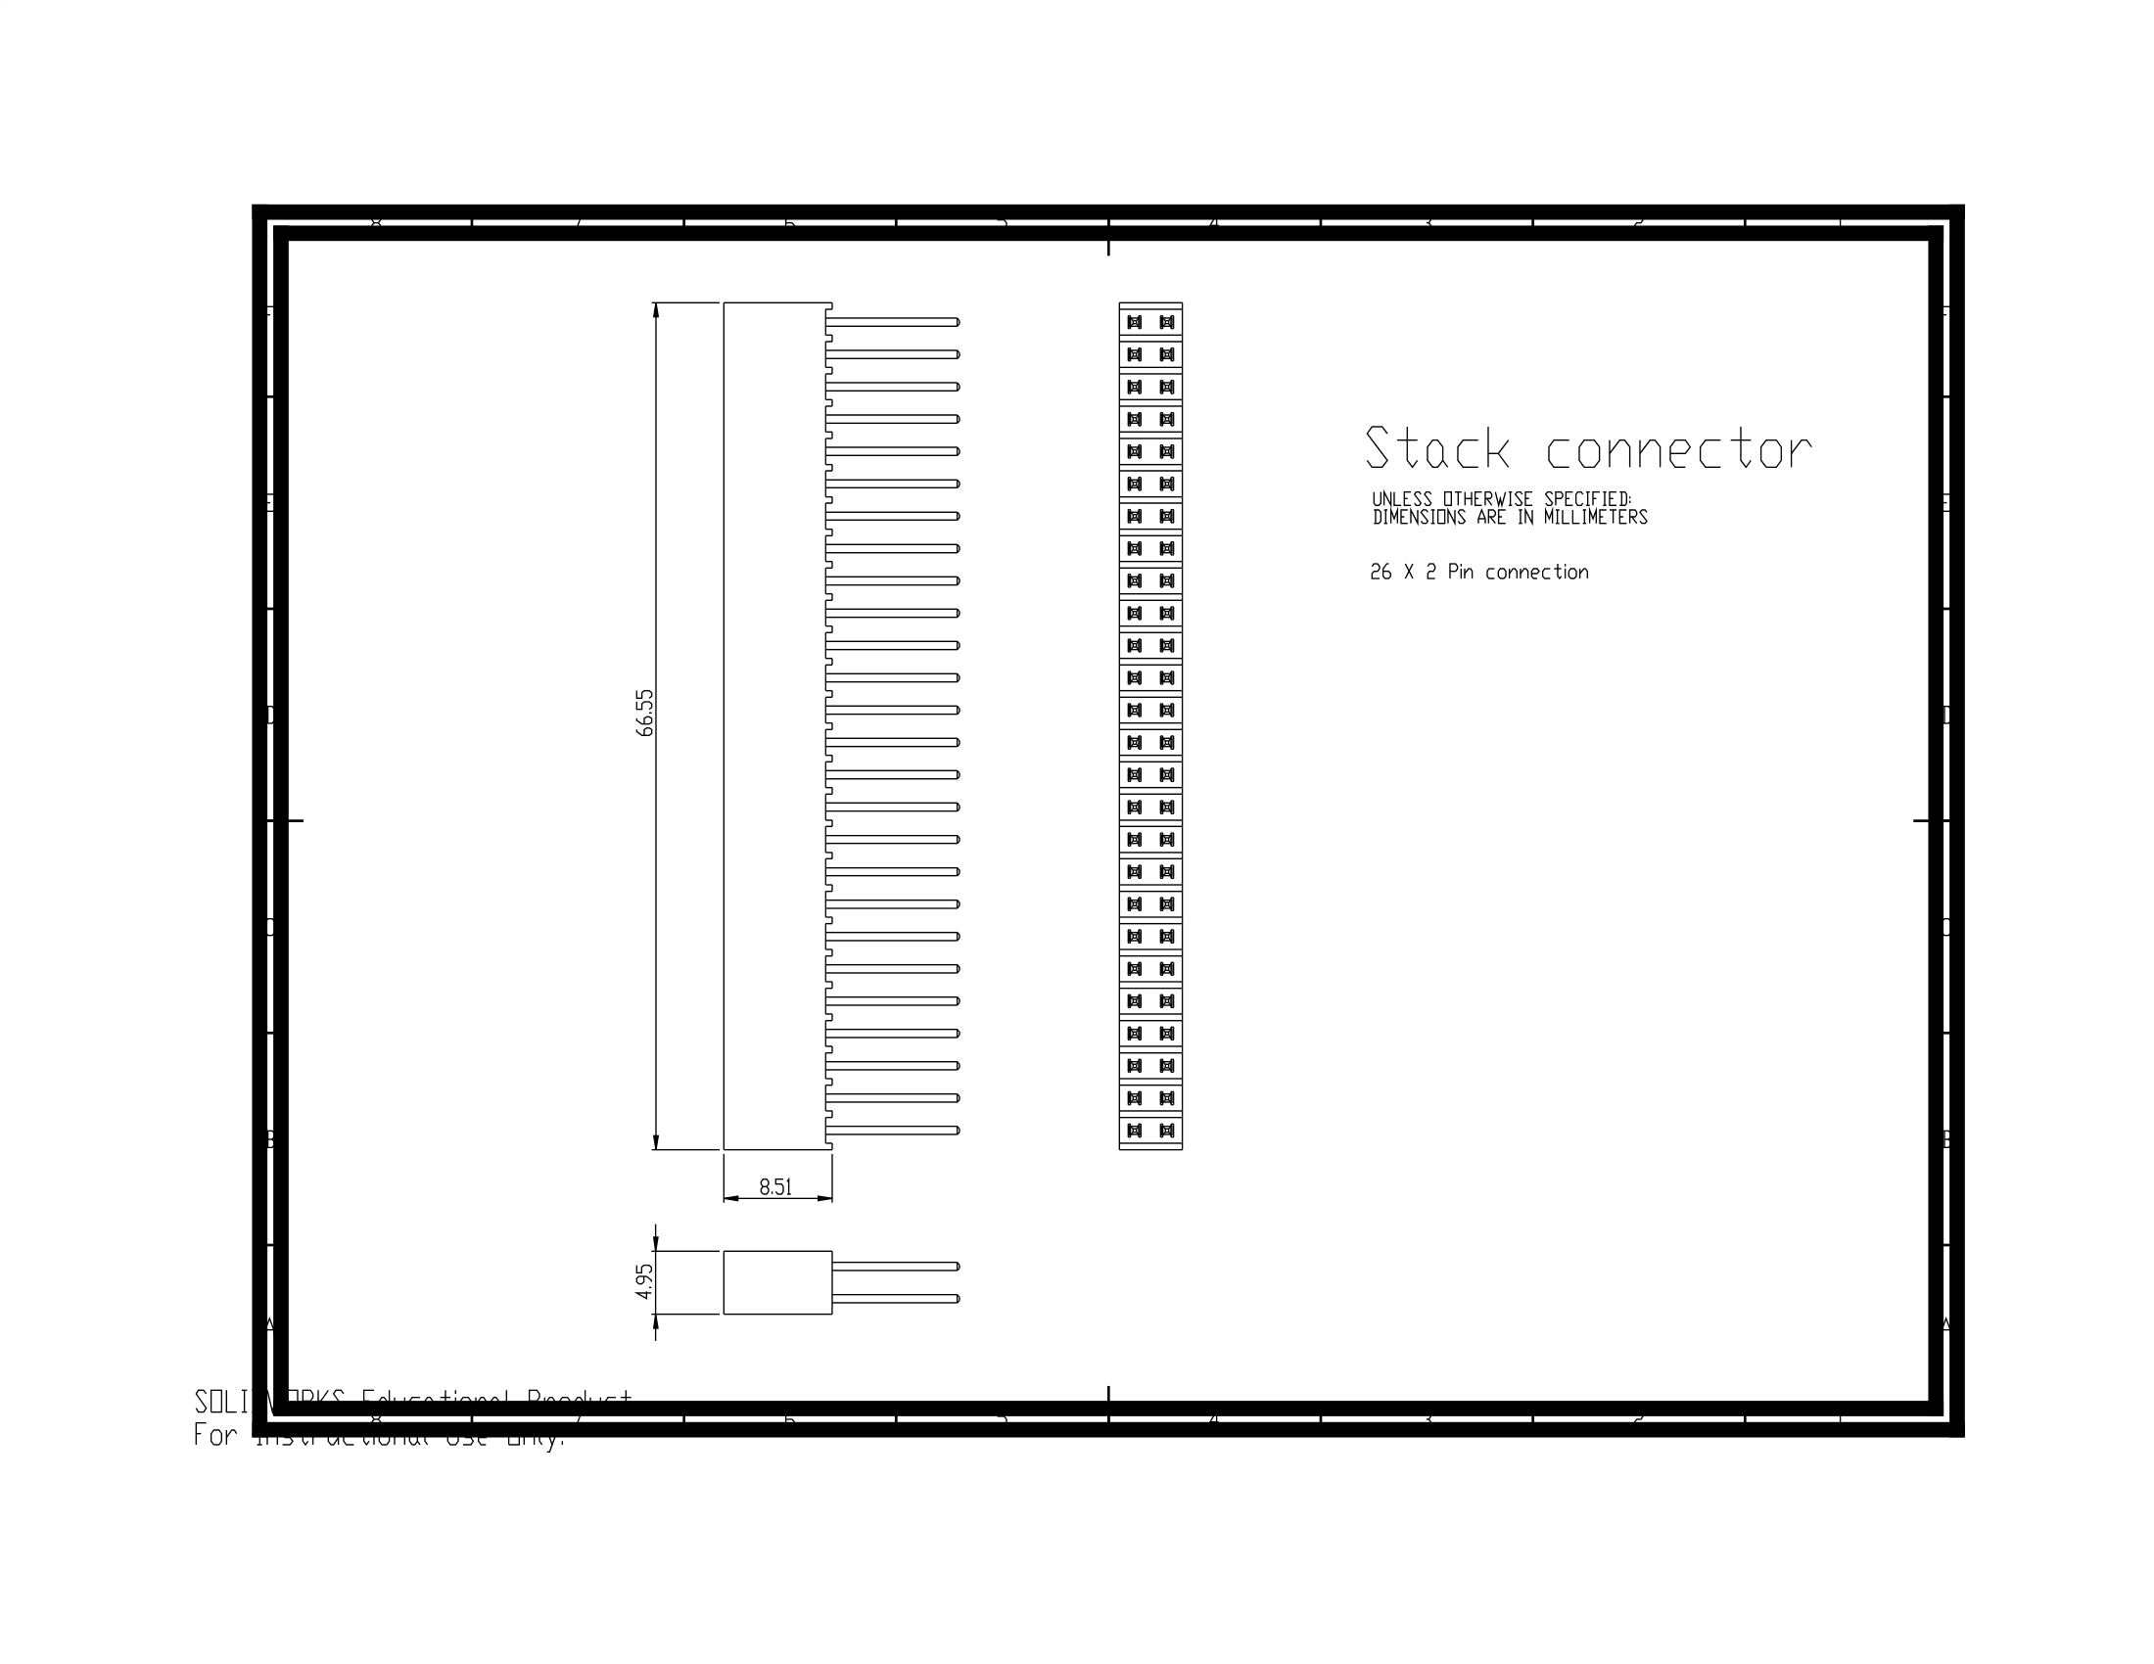

*NanoSense Fine Sun Sensor*

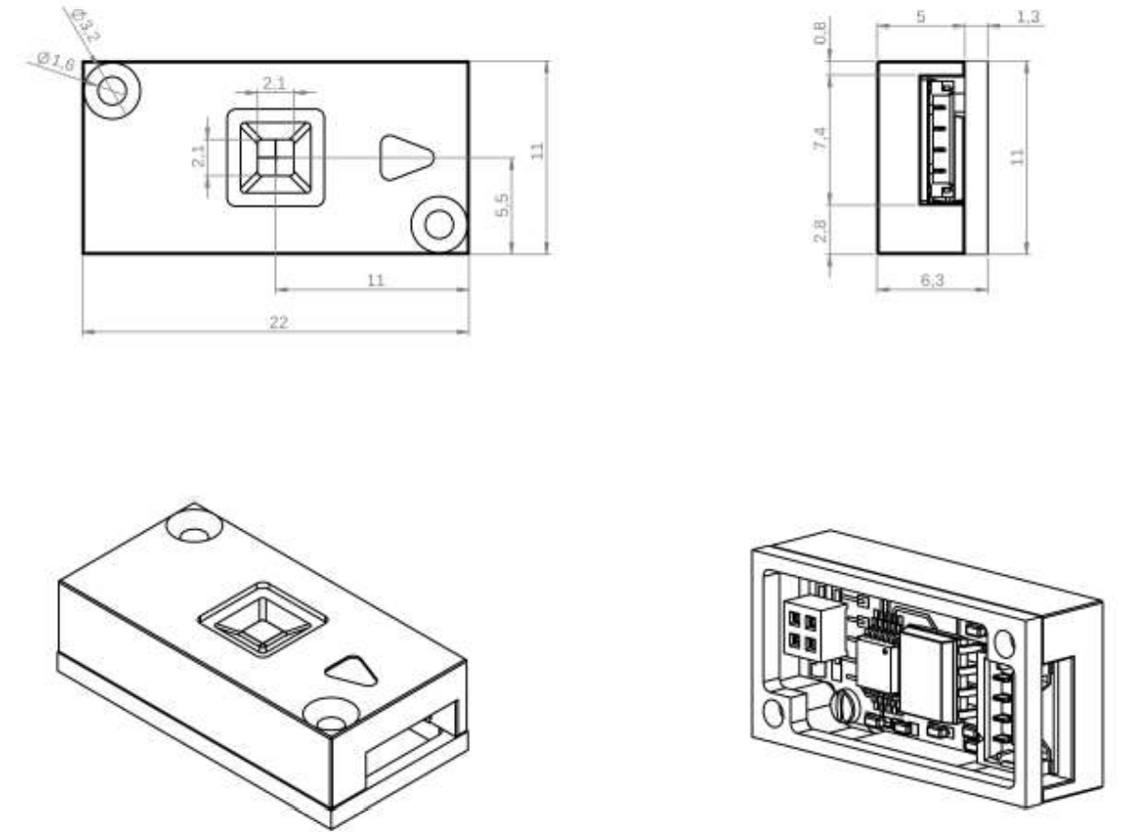

#### 10.2.5 Custom PCBs

*Gyro and reaction wheel*

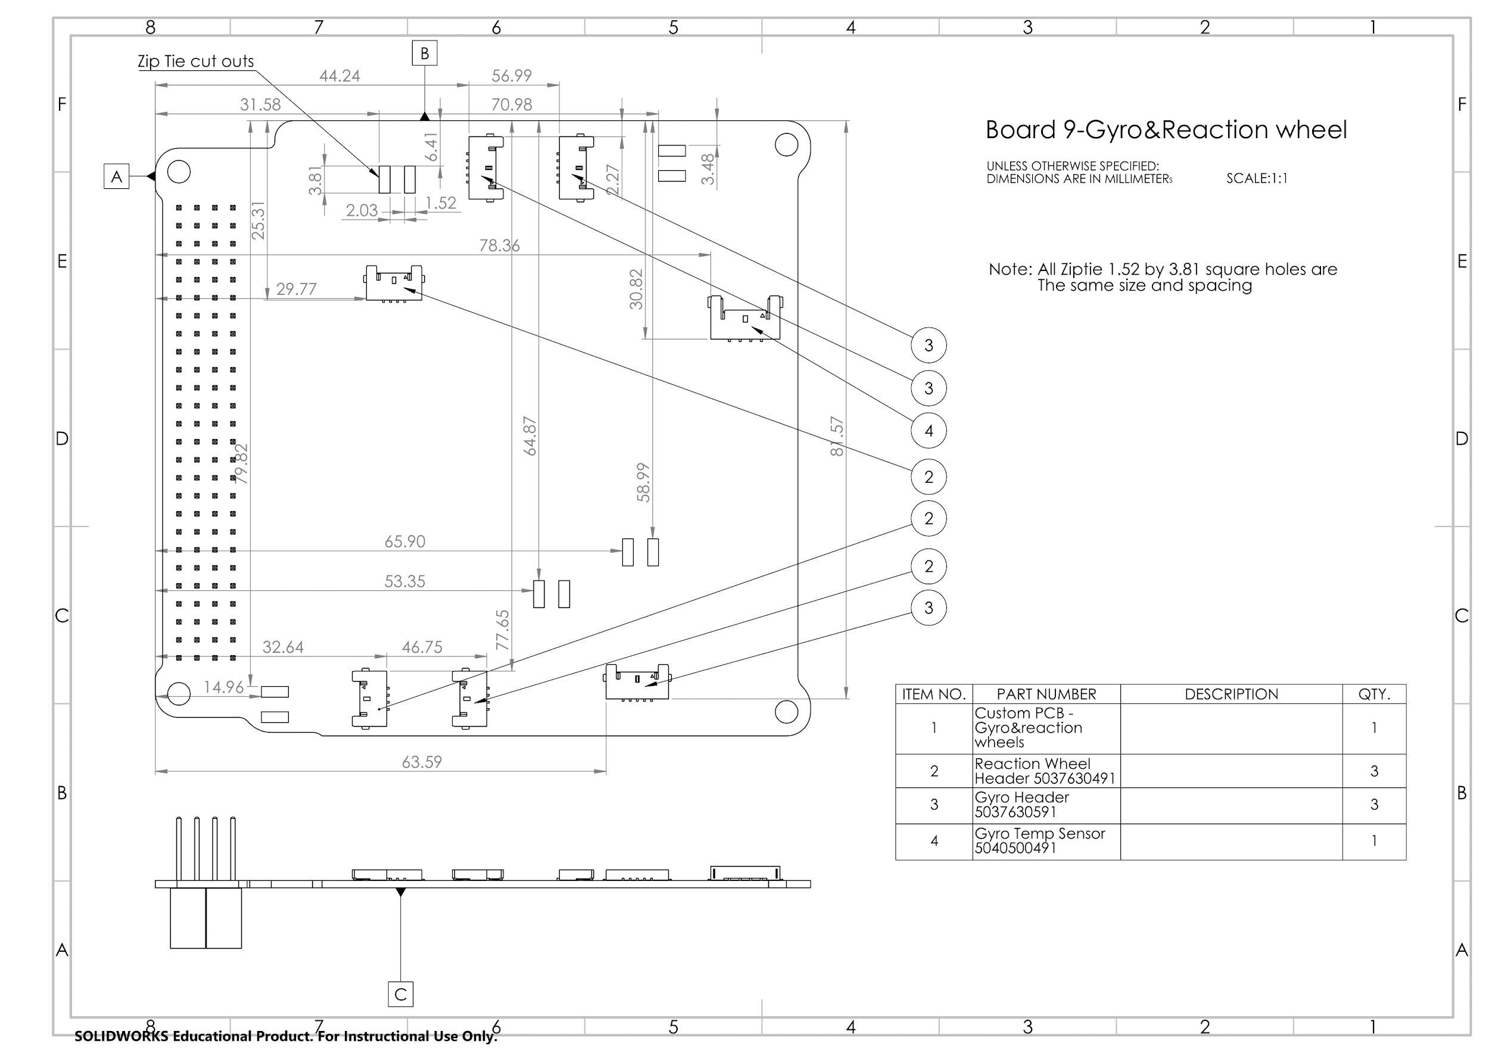

*Camera Board*

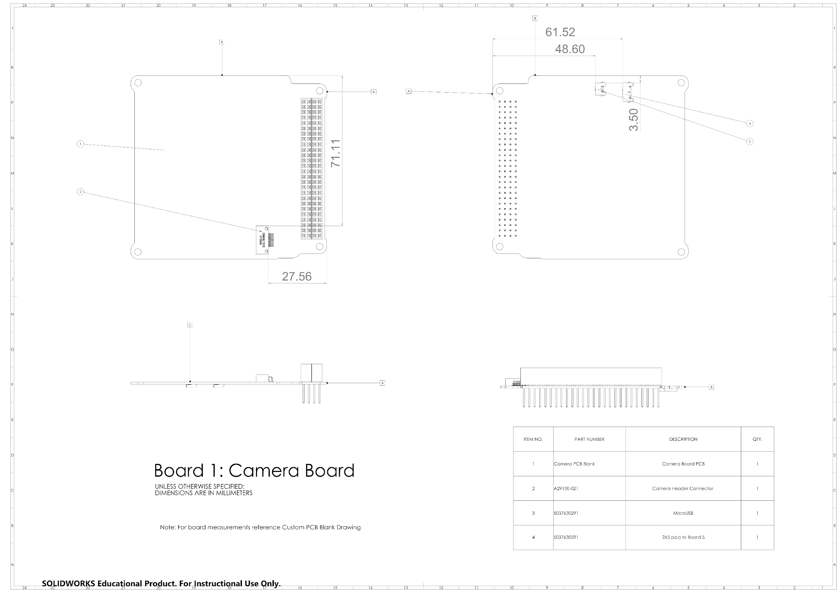

*Custom PCB*

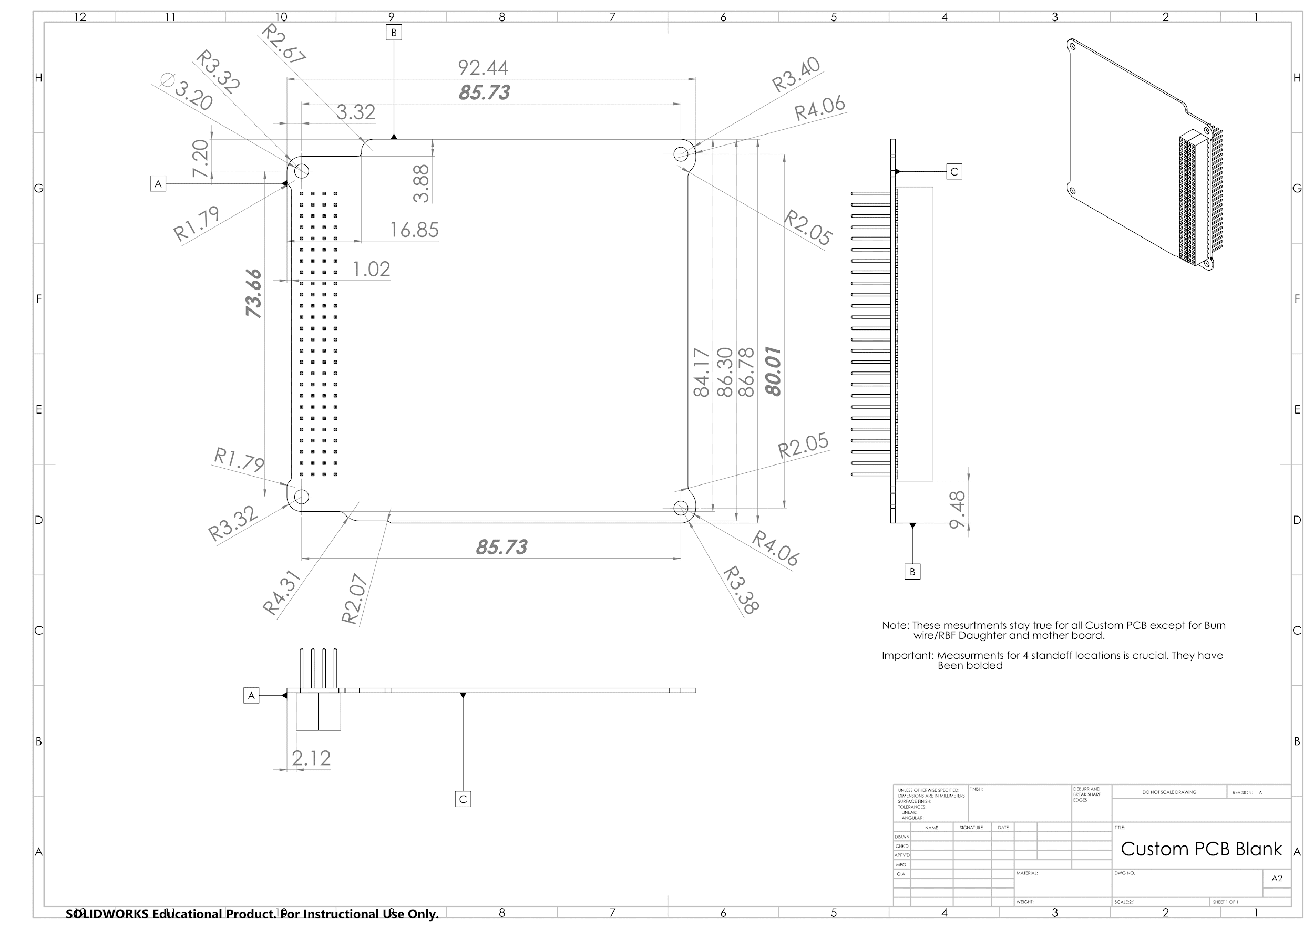

*NanoDock DMC-3*

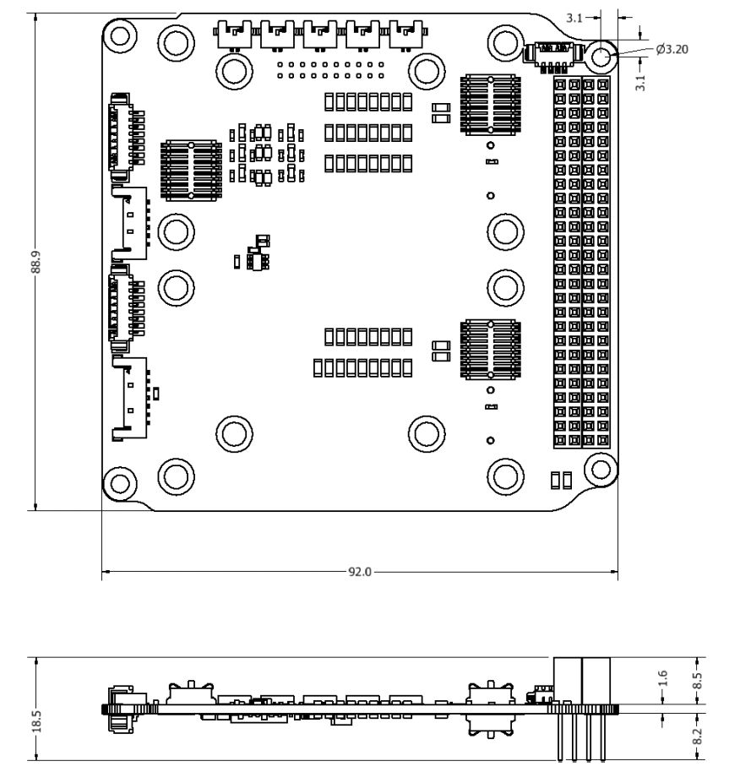

## 10.3 LIST OF TABLES

2.2.2.1 First Unit Components

2.2.2.2 Second Unit Components

2.2.2.3.Third Unit Components

3.1.3.1 Screws

3.1.3.2 Nuts

3.1.3.3 Standoffs

5.1.5 Wire harness lengths

8.1 Mass Budget

8.2 Volume Budget

8.3. Thermal Analysis and CubeSat Temperature Ranges

## 

## 

# REFERENCES

[1] J. P. Monteiro, R. M. Rocha, A. Silva, R. Afonso, and N. Ramos, “Integration and Verification Approach of ISTSat-1 CubeSat,” Aerospace, vol. 6, no. 12, p. 131, Dec. 2019. Accessed: Jan. 17, 2021. [Online]. Available: https://www.mdpi.com/2226-4310/6/12/131/htm

[2] L. A. Ziegler, “Configuration, manufacture, assembly, and integration of a university microsatellite,” M.S. thesis, Dept. Aerospace Eng., Univ. Missouri-Rolla, Rolla, Missouri, United States, 2007. [Online]. Available: https://scholarsmine.mst.edu/cgi/viewcontent.cgi?article=5578&context=masters_theses

[3] J. Chin *et al*., *CubeSat 101: Basic Concepts and Processes for First-Time CubeSat Developers*. (2017). Accessed: Jan. 17, 2021. [Online]. Available: https://www.nasa.gov/sites/default/files/atoms/files/nasa_csli_cubesat_101_508.pdf

[4] Y. Byeloborodov, “2U Cubesat Structural Design and Integration,” M.S. thesis, Coll. Sci., Morehead State Uni., Morehead, Kentucky, United States, 2017. [Online]. Available: https://scholarworks.moreheadstate.edu/cgi/viewcontent.cgi?article=1093&context=msu_theses_dissertations

[5] S. Song, H. Kim, and Y. Chang, “Design and Implementation of 3U CubeSat Platform Architecture,” Korea Aerospace University, Goyang City, Republic of Korea, 2018. Accessed: Jan. 17, 2021. [Online]. Available: <https://www.hindawi.com/journals/ijae/2018/2079219/>

[6] V. U. J. Nwankwo, N. N. Jibiri, and M. T. Kio, “The impact of space radiation environment on satellites operation in near-earth space,” *IntechOpen*, 08-Jun-2020. [Online]. Available: https://www.intechopen.com/chapters/70180. [Accessed: 17-Oct-2021].

[7] Anderson, B. J., “Effects of Radiation on LEO,” *Help: Satellite irradiation*. [Online]. Available: https://www.spenvis.oma.be/help/background/illumination/illumination.html. [Accessed: 17-Oct-2021].

[8] “(PDF) Earth albedo perturbations on low Earth orbit Cubesats.” [Online]. Available: https://www.researchgate.net/publication/264139962_Earth_Albedo_perturbations_on_Low_Earth_Orbit_Cubesats. [Accessed: 17-Oct-2021].